**MINISTRY OF EDUCATION AND TRAINING**

**FPT UNIVERSITY**

Capstone Project Document

Equipment’s Classroom Management

|  |  |
| --- | --- |
| Group 10 | |
| **Group member** | Tran Vinh Quang – SE61078  Tang Viet Hung – SE61019  Doan Nguyen Minh Chi – SE60717 |
| **Supervisor** | Kieu Trong Khanh |
| **Ext. Supervisor** | N/A |
| **Capstone Project Code** | ECRM |

-Ho Chi Minh City, May 11, 2015-

Table of Contents

**Table of Contents 3**

**List of Tables 7**

**List of Figures 8**

**Definitions, Acronyms and Abbreviations 9**

**A. Introduction 10**

**1. Project Information 10**

**2. Introduction 10**

**3. Current Situation 10**

**4. Problem Definition 10**

**5. Proposed Solution 10**

**5.1. Feature Function 10**

**5.2. Advantages and disadvantages 11**

**6. Functional Requirement 11**

**6.1. Equipment Management 11**

**6.2. Notification 12**

**6.3. Room Type Management 12**

**6.4. Classroom Management 12**

**6.5. Damaged Analysis And Recommendations 12**

**6.6. Suggest Available Classroom 12**

**6.7. Manage Account 12**

**7. Role and Responsibility 12**

**B. Software Project Management Plan 13**

**1. Problem Definition 13**

**1.1. Name of this Capstone Project 13**

**1.2. Problem Abstract 13**

**1.3. Project Overview 13**

**1.3.1. Current Situation 13**

**1.3.2. The proposed system 13**

**1.3.3. Boundaries of the System 14**

**1.3.4. Development Environment 14**

**1.3.4.1. Hardware requirements 15**

**1.3.4.2. Software requirements 15**

**2. Project organization 15**

**2.1. Software Process Model 15**

**2.2. Roles and responsibilities 16**

**2.3. Tools and Techniques 17**

**3. Project Management Plan 17**

**3.1. Software development life cycle 17**

**3.2. Phase Detail 18**

**3.2.1. Phase 1: Room Type Management. 18**

**3.2.2. Phase 2: Classroom Management. 19**

**3.2.3. Phase 3: Equipment Management. 19**

**3.2.4. Phase 4: Web Service. 20**

**3.2.5. Phase 5: Android Application. 20**

**3.3. All Meeting Minutes 21**

**4. Coding Convention 21**

**C. Software Requirement Specification 22**

**1. User Requirement Specification 22**

**1.1. Guest Requirement 22**

**1.2. User Requirement 22**

**1.3. Staff Requirement 22**

**1.4. Administrator Requirement 23**

**2. System Requirement Specification 23**

**2.1. External Interface Requirement 23**

**2.1.1. User Interface 23**

**2.1.2. Hardware Interface 23**

**2.1.3. Software Interface 23**

**2.1.4. Communication Protocol 23**

**2.2. System Overview Use Case 23**

**2.3. List of Use Case 24**

**2.3.1. <Guest> Overview Use Case 24**

**2.3.2. <Guest> Login 25**

**2.3.3. <User> Overview Use Case 27**

**2.3.4. <User> View Report History 27**

**2.3.5. <User> View Room Map 29**

**2.3.6. <User> Create Report 30**

**2.3.7. <Staff> Use Case Overview 33**

**2.3.8. <Staff> Create New Room Type 34**

**2.3.9. <Staff> Update Room Type 37**

**2.3.10. <Staff> Remove Room Type 41**

**2.3.11. <Staff> Create Classroom 43**

**2.3.12. <Staff> Update Classroom 44**

**2.3.13. <Staff> Remove Classroom 46**

**2.3.14. <Staff> Resolve Report 48**

**2.3.16. <Staff> View Statistic 53**

**2.3.17. <Staff> Mapping Schedule Manual 54**

**2.3.18. <Staff> Mapping Schedule Import File 56**

**2.3.19. <Authorized User> Use case overview 57**

**2.3.20. <Authorized User> Logout 58**

**2.3.21. <Authorized User> View Profile 59**

**2.3.22. <Authorized User> Update Account 61**

**2.3.23. <Administrator> Use case Overview 63**

**2.3.24. < Administrator> Add Account 63**

**2.3.25. <Administrator> Activate/Deactivate Account 65**

**2.3.26. <Administrator> Update Account 67**

**2.3.27. <Administrator> Remove Account 69**

**2.3.28. <System> Use case Overview 70**

**2.3.29. <System> Notify about fixed 71**

**2.3.30. <System> Send SMS 73**

**2.3.31. <System> Suggest Available Room 74**

**2.3.32. <System> Notify about damaged 75**

**3. Software System Attribute 76**

**3.1. Usability 76**

**3.1.1. Graphic User Interface 76**

**3.1.2. Usability 76**

**3.1.3. Installation 77**

**3.2. Reliability 77**

**3.3. Availability 77**

**3.4. Security 77**

**3.5. Maintainability 77**

**3.6. Portability 77**

**3.7. Performance 77**

**4. Conceptual Diagram 77**

**List of Tables**

Table 1: Role and Responsibility 12

Table 2: Hardware Requirement for system 15

Table 3: Roles and Responsibilities Details 16

Table 4: Software development life cycle 18

Table 5: Phase 1: Room Type Management 19

Table 6: Phase 2: Classroom Management 19

Table 7: Phase 3: Equipment Management 20

Table 8: Phase 4: Web Service. 20

Table 9: Phase 5: Android Application 21

Table 10: <Guest> Login 27

Table 11: <User> View Report History 29

Table 12: <User> View Room Map 30

Table 13: <User> Create Report 33

Table 14: <Staff> Create Room Type 37

Table 15: <Staff> Update Room Type 41

Table 16: <Staff> Remove Room Type 43

Table 17: <Staff> Create Classroom 44

Table 18: <Staff> Update Classroom 46

Table 19: <Staff> Remove Classroom 48

Table 20: <Staff> Resolve Report 51

Table 21: <Staff> Remove Report 53

Table 22: <Staff> Mapping Schedule Manual 56

Table 23: <Staff> Mapping Schedule Import File 57

Table 24: <Authorized User> Logout 59

Table 25: <Authorized User> View Profile 61

Table 26: <Authorized User> Update Account 63

Table 27: <Administrator> Add New Account 65

Table 28: <Administrator> Activate/Deactivate Account 67

Table 29: <Administrator> Update Account 69

Table 30: <Administrator> Remove Account 70

Table 31: <System> Notify about fixed 73

Table 32: <System> Send SMS 74

Table 33: <System> Suggest Available Room 75

Table 34: <System> Notify about damaged 76

# List of Figures

Figure 1: Iterative Development Model 15

Figure 2: System Overview Use Case 24

Figure 3: Guest Overview Use Case 25

Figure 4: <Guest> Login 25

Figure 5: <User> Overview Use Case 27

Figure 6: <User> View Report History 27

Figure 7: <User> View Room Map 29

Figure 8: <User> Create Report 31

Figure 9: <Staff> Use case Overview 34

Figure 10: <Staff> Create Room Type 35

Figure 11: <Staff> Update Room Type 38

Figure 12: <Staff> Remove Room Type 41

Figure 13: <Staff> Create Classroom 43

Figure 14: <Staff> Update Classroom 45

Figure 15: <Staff> Remove Classroom 47

Figure 16: <Staff> Resolve Report 48

Figure 17: <Staff> View Statistic 53

Figure 18: <Staff> Mapping Schedule Manual 54

Figure 19: <Staff> Mapping Schedule Import File 56

Figure 20: <Authorized User> Logout 58

Figure 21: <Authorized User> View Profile 59

Figure 22: <Authorized User> Update Account 61

Figure 23: <Administrator> Add Account 63

Figure 24: <Administrator> Activate/Deactivate Account 65

Figure 25: <Administrator> Update Account 67

Figure 26: <Administrator> Remove Account 69

Figure 27: <System> Use case Overview 71

Figure 28: <System> Notify about fixed 72

Figure 29: <System> Send SMS 73

Figure 30: <System> Suggest Available Room 74

Figure 31: <System> Notify about damaged 75

Figure 32: Conceptual Diagram 78

# Definitions, Acronyms and Abbreviations

|  |  |
| --- | --- |
| Name | Definitions |
| ECRM | Equipment’s Classroom Management |
| HTTP | Hyper Text Transfer Protocol |
| App | Application |
| API | Application Program Interface |

1. **Introduction**
   1. **Project Information**

* Project Name**: Equipment Classroom Management.**
* Project Code**: ECRM.**
* Product Type**: Web Application, Mobile Application.**
* Start Date**: May 11, 2015.**
* End Date**:** 
  1. **Introduction**

Nowadays, numbers of equipment in school are increasing with the rising of students and makes equipment management becoming more important. Therefore, our project looks to meet the demand of managing equipment. We provide website and mobile application for user to send and receive notification about damaged equipment, analyze damaged level to make recommendations, find available classroom and send SMS for related persons, view equipment statistics.

* 1. **Current Situation**

At the moment, all the equipment in the school is not managed by any software. Staff has to gather much information such as number of classroom, status of classroom, status of equipment in each room…., each 6 or 12 months they must check all the equipment about the damaged. When there is any problem occurred, teacher has to report directly to staff and it causes wasting time to report. After that, staff will track status, notice to fixer to fix this. In the other hand, staff must check which room is available if changing is needed.

* 1. **Problem Definition**

Advantages:

* Requires less human resources.

Disadvantages:

* Wasting time to report problem.
* Hard to manage equipment by document, book…
* Hard to find available room when needed.
  1. **Proposed Solution**

Building the application supports the staff manage the equipment’s classroom. The classroom type is present with position of each equipment. The user can report their damage by checking, then that report is notified to staff. The staff also notify to the reported about fixing.

* + 1. **Feature Function**

Staff can:

* Create room type and mapping to each class in school.
* Manage equipment in school.
* Create schedule by import schedule excel file.
* View equipment current status and statistic.
* Receive notification about damaged equipment.
* Resolve notification and notice to reporter.

Admin can:

* Create account and manage all account of system.
* Manage configuration

Teacher can:

* Send notification about damaged equipment.
* Receive notify about fixed or changing room

System can:

* Analyze damaged level and give recommendations.
* Find available classroom.
* Send SMS.
  + 1. **Advantages and disadvantages**
* Advantages
* The report is created easier and faster. Saving time for equipment staff.
* Easy to find the available room if changing room is needed.
* The notifications are received real-time, so the equipment will fix faster.
* Easy to make decision thanks to recommendations from system.
* Staff easily finds the position of failure equipment which shows in classroom map.
* Equipment histories are researched exactly and quickly.
* Show statistics about equipment’s status, using time…
* Disadvantages
* The system would not check the behavior of user, so if the report is not correct, the notification will be wrong.
* System can’t apply to complicated classroom likes discuss room…
* The system could not check validate data imported from excel file.
* User must have internet connection to use this.
  1. **Functional Requirement**

Function requirements of the system are listed as below:

* + 1. **Equipment Management**
* Support to manage all equipment in school.
* Track status equipment.
  + 1. **Notification**
* Report the damage about equipment by checking. This also send notify to staff.
* Check the notification and fixing the equipment.
* Notify to reporter about that fix.
* Send SMS.
  + 1. **Room Type Management**
* Support staff to manage all type of room in school. Staff can create type of room and map with class in school.
  + 1. **Classroom Management**
* Support to manage all classrooms in school.
* Track status of classroom.
  + 1. **Damaged Analysis And Recommendations**
* Analyze about damaged level of classroom and give recommendations.
  + 1. **Suggest Available Classroom**
* Find a similar available classroom with the current classroom.
  + 1. **Manage Account**
* Admin can manage user’s account
* Admin is the person creates all account of system.
  1. **Role and Responsibility**

|  |  |  |  |  |
| --- | --- | --- | --- | --- |
| No | Full Name | Role | Position | Contact |
| 1 | Kiều Trọng Khánh | Project Managers | Instructor | khanhkt@fpt.edu.vn |
| 2 | Trần Vĩnh Quang | Developer | Leader | quangtvse61078@fpt.edu.vn |
| 3 | Tăng Việt Hưng | Developer | Member | hungtvse61019@fpt.edu.vn |
| 4 | Đoàn Nguyễn Minh Chí | Developer | Member | chidnmse60717@fpt.edu.vn |
| 5 |  |  |  |  |

Table 1: Role and Responsibility

1. **Software Project Management Plan**
   1. **Problem Definition**
      1. **Name of this Capstone Project**

* **Official Name:** Equipment’s Classroom Management.
* **Vietnamese Name:** Ứng dụng hỗ trợ quản lí trang thiết bị cho các phòng học
* **Abbreviation:** ECRM
  + 1. **Problem Abstract**

Reporting damaged equipment in classroom is very important. It affect the quality of teaching badly since it caused wasting time. If we can optimize it, the quality of teaching will improve. So the ECRM system will provide the platform where people can reduce reporting damaged equipment time, manage equipment and receive suggestions via web site and mobile application.

* + 1. **Project Overview**
       1. **Current Situation**

The ECRM is the system that helps manages equipment in classroom more convenient way. With teacher, they just click (with web app version) or touch (with mobile app version) on the equipment which is damaged and system will notify to the staff immediately. With staff, they can see specific equipment was damaged in which classroom and who reported it. They can also check which classroom is available due to the schedule excel file imported to the system. Staff can read the statistic about equipment in school if they want to.

The system also has restrictions and it comes from the data in schedule excel file. If staff imports incorrect data but match the template, the result will be wrong. One more thing is the system couldn’t check user’s behaviors. So if teacher report wrong position of the damaged equipment, there are no way the system can deal with it.

* + - 1. **The proposed system**

Our system includes three main subsystems: an online website application for teacher and staff, a mobile application for teacher and a mobile application for staff.

* + - * 1. **Website application**
* Classroom management:
* Staff can create a new classroom.
* Staff can edit classroom.
* Room type management:
* Staff can create a new room type.
* Staff can edit room type.
* Notify about damaged equipment:
* Staff can receive notification about the damaged equipment.
* Teacher can send notification.
* Equipment management:
* Staff can manage equipment.
* Staff can manage equipment information.
* Create or mapping schedule by import excel file:
* Staff can import the schedule excel file into the system and system will create a schedule.
* Statistic:
* Staff can read statistic about the equipment likes life time, current status…
* Analysis:
  + System analyzes the damaged level and gives suggestions.
* Send SMS:
  + System sends SMS to related peoples.
* Suggest available classroom:
  + System find similar available classroom with current classroom and give suggestion.
    - * 1. **Mobile application for teacher**
* Teacher sends notification about damaged equipment.
* Teacher sees the map of room with interactive graphic in their account.
* Teacher receives notification about fixed equipment or changing room if needed.
  + - * 1. **Mobile application for staff**
* Staff can get notification from damaged equipment which reported by teacher.
* Staff can send notification to teacher about fixing equipment of changing room if needed
* Staff can send SMS to relative people such as: teacher, security…
* Staff can check status of all room in school.
  + - 1. **Boundaries of the System**
* The ECRM is used by teacher and staff, run in laptop, PC and android smart phone.
* Language: English.
* The lasted product contain:
* The website application for staff and teacher.
* The android application for staff.
* The android application for teacher.
  + - 1. **Development Environment**
         1. **Hardware requirements**

**For system**

|  |  |  |
| --- | --- | --- |
| Windows | Minimum Requirements | Recommended |
| Operating System | Window Sever 2008 | Window Server 2012 |
| Computer Processor | 512MB RAM | 2GB RAM or more |
| Computer Memory | Intel**®** Core 2 duo | Intel**®** Core™ i5 CPU, M460 @2.53 GHz |
| Internet Connection | Cable, WIFI (2 Mbps) | Cable, WIFI (4Mbps) |

Table 2: Hardware Requirement for system

* + - * 1. **Software requirements**
* Window Server 2008: Operating system for deploy web service.
* SQL Server 2008 Enterprise R2: used to create and manage the database for system.
* StarUML v5.0: used to created models and diagrams.
* Skype 7.0: used for communication and meeting.
* IntelliJ IDEA 14.0.3, JDK 7, Apache Tomcat 7, Android SDK 14: used to implement web application, web service, and mobile application.
* Github & TortoiseSVN 1.8: used for source control.
  1. **Project organization**
     1. **Software Process Model**

The model for project is: Iterative Development Model

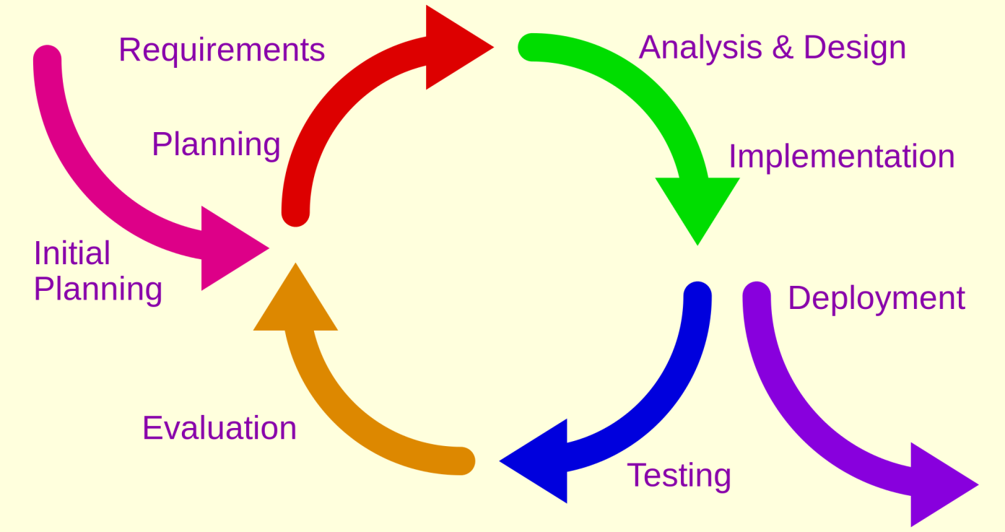

Figure 1: Iterative Development Model

Source: <http://en.wikipedia.org/wiki/Iterative_and_incremental_development>

The reasons for choose iterative development are:

* Members are active but lack of experience so we need to receive feedback during project evolving.
* We have 14 weeks for this project. So we can defined this is small project. Iterative model is suitable for this project to approaching the user thinking.
* This project does not exist, so we must take the survey to customer to know the equipment management in each school.
* In each phase, members only focus for their function. This will make the result better.
* Customer is more actively involved, get higher priority.
* Requirement changed frequently.
  + 1. **Roles and responsibilities**

|  |  |  |  |
| --- | --- | --- | --- |
| **No** | **Full name** | **Role in Group** | **Responsibilities** |
| **1** | Kieu Trong Khanh | Project manager | * Specify user requirement * Control the development process * Give out technique and business analysis support |
| **2** | Tran Vinh Quang | Team Leader, BA, Developer, Tester | * Managing process * Designing database * Clarifying requirements * Prepare documents * GUI design * Create test plan * Coding * Testing |
| **3** | Tang Viet Hung | Team Member, Developer, Tester | * Designing database * Clarifying requirements * Prepare documents * GUI design * Create test plan * Coding * Testing |
| **4** | Doan Nguyen Minh Chi | Team Member, Developer, Tester | * Designing database * Clarifying requirements * Prepare documents * GUI design * Create test plan * Coding * Testing |

Table 3: Roles and Responsibilities Details

* + 1. **Tools and Techniques**
* Front-end: HTML 5, Bootstrap, CSS3, JavaScript, jQuery.
* Back-end: RESTful Web service, Spring MVC, Hibernate,
* Web-server: Apache Tomcat 7.0.
* Database Management System: MS SQL Server 2008 Enterprise R2
  1. **Project Management Plan**
     1. **Software development life cycle**

|  |  |  |  |  |  |
| --- | --- | --- | --- | --- | --- |
| **Phase** | **Description** | **Deliverables** | **Resource needed** | **Dependencies and Constrains** | **Risk** |
| **Room Type Management** | * Support to create, edit room type. | * Website application allowed creating, editing room type of school. * Related document (SRS, SDD, User Guide…) |  | N/A | * Lack of experience. * Technology is difficult. * Not have a clear understanding about business process. |
| **Classroom Management** | * Support to create, edit classroom with room type. * Support to check status, change status of room. * Support to import, mapping schedule. * Support to remove, update classroom. | * Website application allowed creating, editing, removing classroom. * Related document (SRS, SDD, User Guide…) |  | Dependence on “Room Type Management” | * Lack of experience. * Technology is difficult. * Not have a clear understanding about business process. |
| **Equipment**  **Management** | * Support to manage equipment on school. * Support to check life time… of equipment. | * Website application allowed managing equipment. * Related document (SRS, SDD, User Guide…) |  | N/A | * Lack of experience. * Technology is difficult. * Not have a clear understanding about business process. |
| **Notify damage and fixing** | * Support user to notify about damaged equipment. * Support staff to notify about fixing. | * Website application allowed user receive notify. * Related document (SRS, SDD, User Guide…) |  | Dependence on “Manage Classroom”, “Manage Equipment” | * Lack of experience. * Technology is difficult. * Not have a clear understanding about business process. |
| **Web Service** | * Build web service to develop android application. | * Web service provides API. * Related document (SRS, SDD, User Guide…) |  | Dependence on “Notify damage and fixing” | * Lack of experience. * Technology is difficult. * Not have a clear understanding about business process. |
| **Android Application** | * Support user to notify about damaged equipment and receive notification in their smartphone using Android OS with internet connection. | * Android application allow user send notify about damage. * Related document (SRS, SDD, User Guide…) |  | Dependence on “Web Service” | * Lack of experience. * Technology is difficult. * Not have a clear understanding about business process. |

Table 4: Software development life cycle

* + 1. **Phase Detail**
       1. **Phase 1: Room Type Management.**

|  |  |  |
| --- | --- | --- |
| **Task** | **Description** | **Author** |
| **Planning** | * Identify start date, end date of iteration. * Identify what team should implement in this iteration. | QuangTV |
| **Requirements** | * Collect requirements from customer * Identify and clarify requirements | QuangTV, HungTV, ChiDNM |
| **Analysis & Design** | * Research and identify technology to implement function * Identify how to implements function * Create ER diagram, database * Create detail design for this function | QuangTV, HungTV, ChiDNM |
| **Implementation** | * Implement function base on detail design, technology had research. | QuangTV, HungTV, ChiDNM |
| **Deployment** | * Create deployment documents, user guide. * Deploy this function to server | QuangTV, HungTV, ChiDNM |
| **Testing** | * Write and run test case for this function * Do unit test and integration test. * Create testing document | QuangTV, HungTV, ChiDNM |
| **Evaluation** | * Receive feedback | QuangTV |

Table 5: Phase 1: Room Type Management

* + - 1. **Phase 2: Classroom Management.**

|  |  |  |
| --- | --- | --- |
| **Task** | **Description** | **Author** |
| **Planning** | * Identify start date, end date of iteration. * Identify what team should implement in this iteration. * Notice about feed of customer about previous iteration to team member. | QuangTV |
| **Requirements** | * Collect requirements from customer * Identify and clarify requirements | QuangTV, HungTV, ChiDNM |
| **Analysis & Design** | * Research and identify technology to implement function * Identify how to implements function * Create, update ER diagram, database * Create detail design for this function | QuangTV, HungTV, ChiDNM |
| **Implementation** | * Implement function base on detail design, technology had research. | QuangTV, HungTV, ChiDNM |
| **Deployment** | * Create deployment documents, user guide. * Deploy this function to server | QuangTV, HungTV, ChiDNM |
| **Testing** | * Write and run test case for this function * Do unit test and integration test. * Update testing document | QuangTV, HungTV, ChiDNM |
| **Evaluation** | * Receive feedback | QuangTV |

Table 6: Phase 2: Classroom Management

* + - 1. **Phase 3: Equipment Management.**

|  |  |  |
| --- | --- | --- |
| **Task** | **Description** | **Author** |
| **Planning** | * Identify start date, end date of iteration. * Identify what team should implement in this iteration. * Notice about feed of customer about previous iteration to team member. | QuangTV |
| **Requirements** | * Collect requirements from customer * Identify and clarify requirements | QuangTV, HungTV, ChiDNM |
| **Analysis & Design** | * Research and identify technology to implement function * Identify how to implements function * Create, update ER diagram, database * Create detail design for this function | QuangTV, HungTV, ChiDNM |
| **Implementation** | * Implement function base on detail design, technology had research. | QuangTV, HungTV, ChiDNM |
| **Deployment** | * Create deployment documents, user guide. * Deploy this function to server | QuangTV, HungTV, ChiDNM |
| **Testing** | * Write and run test case for this function * Do unit test and integration test. * Update testing document | QuangTV, HungTV, ChiDNM |
| **Evaluation** | * Receive feedback | QuangTV |

Table 7: Phase 3: Equipment Management

* + - 1. **Phase 4: Web Service.**

|  |  |  |
| --- | --- | --- |
| **Task** | **Description** | **Author** |
| **Planning** | * Identify start date, end date of iteration. * Identify what team should implement in this iteration. * Notice about feed of customer about previous iteration to team member. | QuangTV |
| **Requirements** | * Collect requirements from customer * Identify and clarify requirements | QuangTV, HungTV, ChiDNM |
| **Analysis & Design** | * Research and identify technology to implement function * Identify how to implements function * Create, update ER diagram, database * Create detail design for this function | QuangTV, HungTV, ChiDNM |
| **Implementation** | * Implement function base on detail design, technology had research. | QuangTV, HungTV, ChiDNM |
| **Deployment** | * Create deployment documents, user guide. * Deploy this function to server | QuangTV, HungTV, ChiDNM |
| **Testing** | * Write and run test case for this function * Do unit test and integration test. * Update testing document | QuangTV, HungTV, ChiDNM |
| **Evaluation** | * Receive feedback | QuangTV |

Table 8: Phase 4: Web Service.

* + - 1. **Phase 5: Android Application.**

|  |  |  |
| --- | --- | --- |
| **Task** | **Description** | **Author** |
| **Planning** | * Identify start date, end date of iteration. * Identify what team should implement in this iteration. * Notice about feed of customer about previous iteration to team member. | QuangTV |
| **Requirements** | * Collect requirements from customer * Identify and clarify requirements | QuangTV, HungTV, ChiDNM |
| **Analysis & Design** | * Research and identify technology to implement function * Identify how to implements function * Create, update ER diagram, database * Create detail design for this function | QuangTV, HungTV, ChiDNM |
| **Implementation** | * Implement function base on detail design, technology had research. | QuangTV, HungTV, ChiDNM |
| **Deployment** | * Create deployment documents, user guide. * Deploy this function to server | QuangTV, HungTV, ChiDNM |
| **Testing** | * Write and run test case for this function * Do unit test and integration test. * Update testing document | QuangTV, HungTV, ChiDNM |
| **Evaluation** | * Receive feedback | QuangTV |

Table 9: Phase 5: Android Application

* + 1. **All Meeting Minutes**

Refer to Meeting Minutes folder

<https://github.com/tranquang9a1/ECRM>

* 1. **Coding Convention**

Java: Using to develop desktop application.

Summary:

* Naming Convention.
  + Use camel case for both variable and function name.
  + Use Pascal case for class, interface name.
  + The names of variables declared constants should be all uppercase with words separated by under-scores (“_”).
* Four spaces should be used as the unit of indentation. The exact construction of the indentation (spaces vs. tabs) is unspecified. Tabs must be set exactly every 8 spaces (not 4).
* When an expression will not fit on a single line, break it according to these general principles:
  + Break after a comma.
  + Break before an operator.
  + Align the new line with the beginning of the expression at the same level on the previous line.
* Declaration.
  + One declaration per line is recommended slice it encourages commenting.
  + In absolutely no case should variables and functions be declared on the same line
  + Do not put different types on the same line.
* Code Examples

Follow “Code Conventions for the Java TM Programming Language, by Sun Microsystems, rev April 20, 1999”.

<http://www.oracle.com/technetwork/java/codeconventions-150003.pdf>.

1. **Software Requirement Specification**
   1. **User Requirement Specification**
      1. **Guest Requirement**

Guest is a person who does not login to the system. Guest can use some function in the system. These are some functions guest can use:

* Login
  + 1. **User Requirement**

User is guest, who uses his account to login to the system. In this system, we can define user is a teacher. Member can use some additional function, such as:

* View Report History
* View Room Map
* Create Report
  + 1. **Staff Requirement**

Staff is manager of the system, we can define staff is an equipment manager in school. Staff can use these function:

* Manage Room Type include:
  + Create New Room Type
  + Update Room Type
  + Delete Room Type
* Manage Classroom include:
  + Create Classroom
  + Update Classroom
  + Remove Classroom
* Map Schedule include:
  + Map Schedule by Import File
  + Map Schedule by Manual
* Statistic
* Manage Report include:
  + Resolve Report
  + Remove Report
    1. **Administrator Requirement**

Admin is the person who manages the system. Admin is super user can use following functions:

* Manage Account include:
  + Add New Account
  + Update Account
  + Remove Account
  + Activate/Deactivate Account
* Manage configuration
  + 1. Authorize User Requirement

Authorize User is the person who login to system include user, staff, administrator. Authorize user can use following functions:

* Logout
* View Profile: They can update information of account.
  1. **System Requirement Specification**
     1. **External Interface Requirement**
        1. **User Interface**
* The user interface uses language Vietnamese
  + - 1. **Hardware Interface**
* N/A
  + - 1. **Software Interface**
* Firefox (v30 or above), Chrome (v14 or above) browser, enable JavaScript
* Smartphone with Android 4.0 or above.
  + - 1. **Communication Protocol**
* Website using HTTP protocol for communication between the web browser and the web server.
* Mobile app using HTTP protocol for communication between app and web service.
  + 1. **System Overview Use Case**

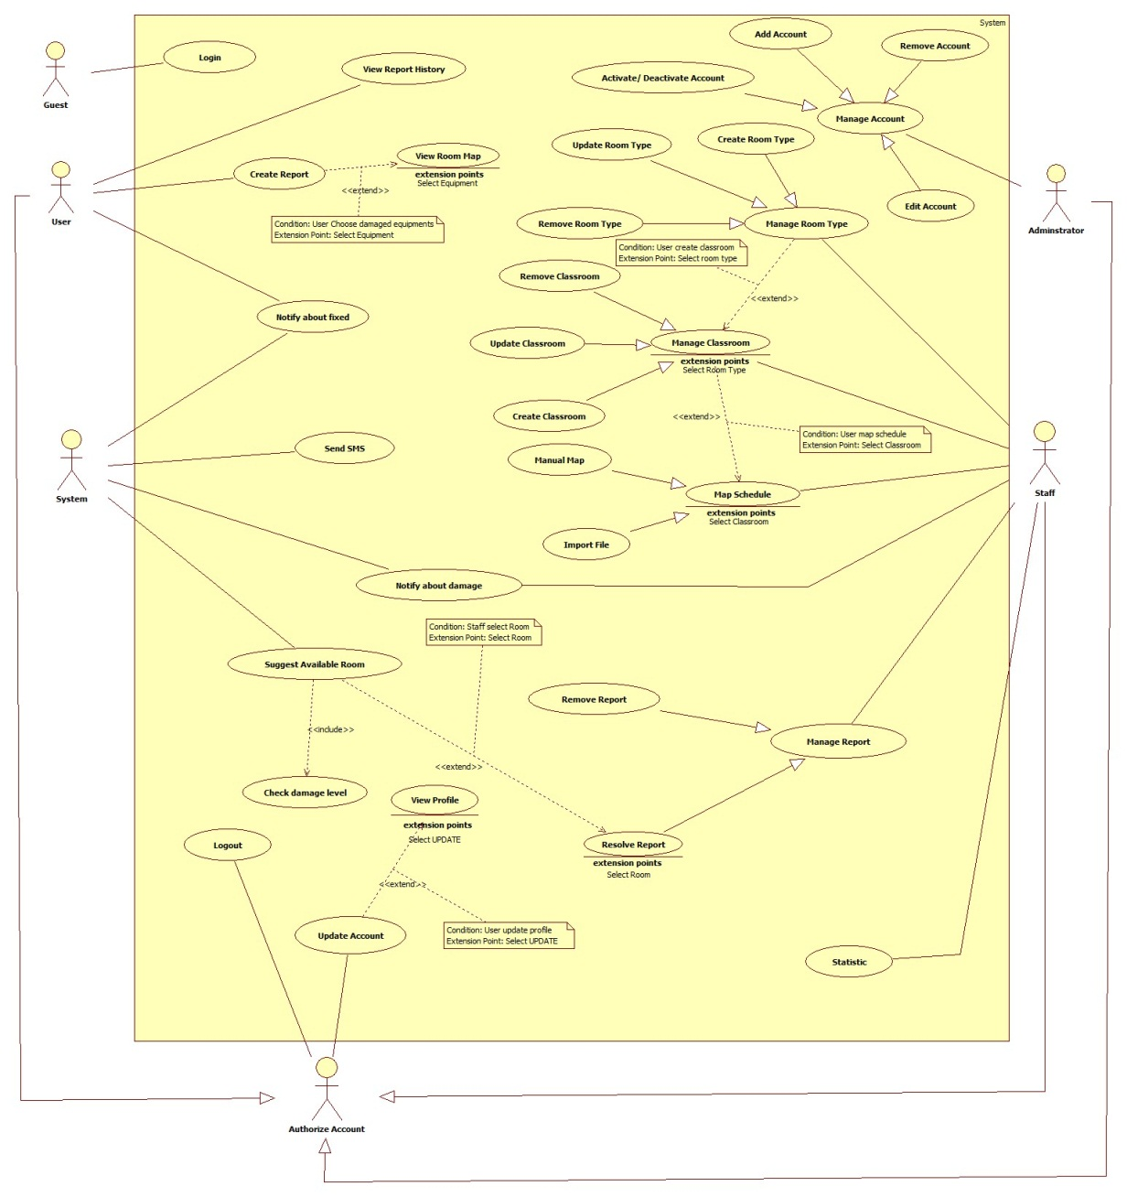

Figure 2: System Overview Use Case

* + 1. **List of Use Case**
       1. **<Guest> Overview Use Case**

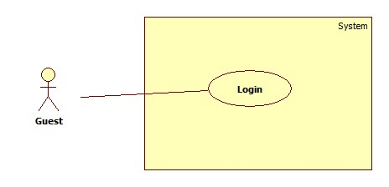

Figure 3: Guest Overview Use Case

* + - 1. **<Guest> Login**



Figure 4: <Guest> Login

Use case Specification

|  |  |  |  |
| --- | --- | --- | --- |
| **USE CASE – ECRM001** | |  |  |
| **Use Case No.** | ECRM001 | **Use Case Version** | 2.0 |
| **Use Case Name** | Login |  |  |
| **Author** | Tang Viet Hung |  |  |
| **Date** | 05/21/2015 | **Priority** | Normal |
| **Actor:** Guest | |  |  |
| **Summary:** This use case allows guest to login.  **Goal:** Authentication and authorization  **Triggers:** Guest send “Đăng nhập” request to system.  **Preconditions:**   * N/A   **Post Conditions:**   * **Success:** Guest will be logged in system with their roles. Show welcome message. * **Fail:** Unsuccessful message will be shown.   **Main Success Scenario:**   |  |  |  | | --- | --- | --- | | Step | Actor Action | System Response | | 1 | Guest send Login request. | System navigates to “Đăng nhập” page.   * Username: free text input, min length: 6, max length: 20 required. * Password: free text input, min length: 6, max length: 20, required. * Đăng nhập: command | | 2 | Input field. |  | | 3 | Guest send “Đăng nhập” request. | Guest will login system with their roles.  [Exception 1,2,3] |     **Alternative Scenario:** N/A    **Exceptions:**   |  |  |  | | --- | --- | --- | | No | Cause | System Response | | 1 | Wrong username or password. | Show unsuccessful message: “Sai username hoặc password. Hãy thử lại!” | | 2 | “Username” field or “Password” field is empty | Show error message: “Bạn chưa nhập Username or Password. Hãy thử lại” | | 3 | “Username” or “Password” field data length is longer than 20 character or lower than 6 character | Show error message: “Username và Password phải lớn hơn 6 và nhỏ hơn 20 ký tự!” |     **Relationships:** N/A  **Business Rules:**   * After login successfully, guest will login with their role: user, staff and administrator. * Only active user can login to system. * If it is first time user login to system. They will be redirect to “Change Password” page to change password. * On mobile application, user can only login ECRM User App. Staff can only login ECRM Staff App. * On website application, if guest login with role user will be redirect to homepage. If guest is staff, they will be redirected to admin page. | | | |

Table 10: <Guest> Login

* + - 1. <User> Overview Use Case

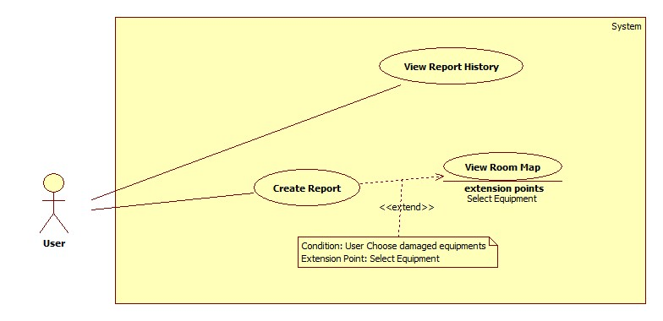

Figure 5: <User> Overview Use Case

* + - 1. <User> View Report History

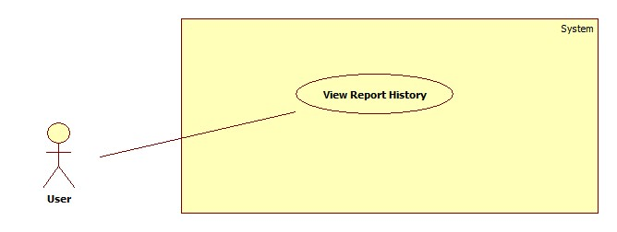

Figure 6: <User> View Report History

**Use case specification**

|  |  |  |  |
| --- | --- | --- | --- |
| **USE CASE – ECRM002** | | | |
| **Use Case No.** | ECRM002 | **Use Case Version** | 2.0 |
| **Use Case Name** | View Report History | | |
| **Author** | Doan Nguyen Minh Chi | | |
| **Date** | 05/21/2015 | **Priority** | Low |
| **Actor:**   * User   **Summary:**   * This use case allows user to view detail resolve for them report.   **Goal:**   * User can view report detail is resolved.   **Triggers:**   * User send request view report history.   **Preconditions:**   * User must be teacher. * This report must be created by user.   **Post Conditions:**   * **Success:** Show report detail and resolve of staff. * **Fail:** Show error message.   **Main Success Scenario:**   |  |  | | --- | --- | | Actor Action | System Response | | User send request view report history. |  | |  | System will show report with two tab:   * “Báo cáo” tab:   + “Phòng”: label   + “Người báo cáo”: label   + “Thời gian báo cáo”: label   + “Thiết bị”: label + “Xem bản đồ” send command   + “Mức độ hư hại”: process   + “Mô tả từ giáo viên”: label * “Khắc phục” tab:   + “Nhân viên”: label   + “Thời gian hoàn thành”: label   + “Cách khắc phục”: label   + “Lý do hư hỏng”: lable * “Thoát” send command   [Exception 1][Exception 2] |   **Alternative Scenario:** N/A  **Exceptions:**   |  |  |  | | --- | --- | --- | | No | Cause | System Response | | 1 | Report history not exist |  | |  | Show warning message: “Báo cáo hiện không tìm thấy.” | | 2 | User view report of other user |  | |  | Show warning message: “Bạn không có quyền truy cập báo cáo này.” |   **Relationships:** N/A  **Business Rules:**   * User only views them report. * User can view report, if report status is fixed. | | | |

Table 11: <User> View Report History

* + - 1. <User> View Room Map

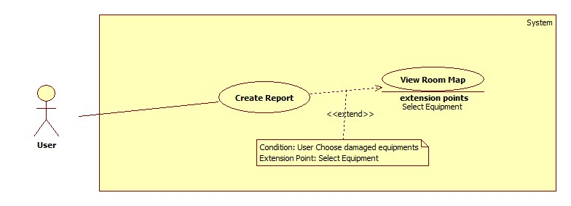

Figure 7: <User> View Room Map

**Use case specification**

|  |  |  |  |
| --- | --- | --- | --- |
| **USE CASE – ECRM003** | |  |  |
| **Use Case No.** | ECRM003 | **Use Case Version** | 2.0 |
| **Use Case Name** | View Room Map |  |  |
| **Author** | Tran Vinh Quang |  |  |
| **Date** | 05/21/2015 | **Priority** | Normal |
| **Actor:** User | |  |  |
| **Summary:** This use case allows user to view map of classroom they teach.  **Goal:** View map of classroom user teaching. (Apply for web application and mobile application)  **Triggers:** User send “View Room Map” request in Home page.  **Preconditions:**   * User has successfully logged in system. * User must teaching in that time.   **Post Conditions:**   * **Success:** User will see map of classroom they teaching. * **Fail:** Unsuccessful message will be shown.   **Main Success Scenario:**   |  |  |  | | --- | --- | --- | | Step | Actor Action | System Response | | 1 | User send “View Room Map” request. | System navigates to “Map” page.  It contains the following information   * Map of room they teaching, show location of all equipment in class include board, table, chair, projector, fan…. * Cancel: button   [Exception 1,2] |     **Alternative Scenario:** N/A  **Exceptions:**     |  |  |  | | --- | --- | --- | | Step | Actor Action | System Response | | 1 | Connection error | Show error message: “Lỗi kết nối, vui lòng tải lại” | | 2 | User does not teach any class | Show error message: “Bạn không dạy lớp nào! Vui lòng thử lại sau hoặc liên hệ với quản lí”. | | 3 | Classroom did not had type | Show error message: “Hiện tại chưa có sơ đồ phòng học này, vui lòng liên hệ với quản lí”. |   **Relationships:** extend by Create Report  **Business Rules:**   * From map page, user can create report about damage equipment by click to equipment in map. * Only user have teaching in class can see map of room. * If class had damaged equipment, that equipment will be showed with red color. Other equipment will be showed with white color * System will check type of classroom and show map to screen. | | | |

Table 12: <User> View Room Map

* + - 1. <User> Create Report



Figure 8: <User> Create Report

**Use case specification**

|  |  |  |  |
| --- | --- | --- | --- |
| **USE CASE – ECRM004** | | | |
| **Use Case No.** | ECRM004 | **Use Case Version** | 2.0 |
| **Use Case Name** | Create report | | |
| **Author** | Doan Nguyen Minh Chi | | |
| **Date** | 05/21/2015 | **Priority** | High |
| **Actor:**   * User   **Summary:**   * In this use case allows user to send report for staff about damaged equipment.   **Goal:**   * Staff will be received damaged report from user. * Teacher sends report about damaged equipment.   **Triggers:**   * User send “Tạo Báo Cáo” request in notification page.   **Preconditions:**   * User has login successful on system with role teacher. * User has teaching schedule in this classroom.   **Post Conditions:**   * **Success:** Report must be send to staff. * **Fail:** Show error message.   **Main Success Scenario:**   |  |  | | --- | --- | | Actor Action | System Response | | 1. User sends “Tạo Báo Cáo” request. |  | |  | 1. System will show classroom map which are used by user.    1. Classroom map: a map showing equipment position    2. “Tiếp theo”: send command | | 1. User must choose damaged equipment, and sends “Tiếp theo” request. |  | |  | 1. Detail report will be shown in form:  * “Phòng”: label * “Thiết bị”: label * “Độ hư hỏng”: value list , required   + “Nặng, không thể sử dụng”   + “Trung bình, khó sử dụng”   + “Nhẹ, cố thể sử dụng” * “Đánh giá của bạn”: value list, required   + “Cần đổi phòng ngay”   + “Cần hổ trợ gấp”   + “Có thể sửa sau” * “Mô tả hư hại”: free text input, min length: 0, max length: 200, optional. * “Gửi báo cáo”: send command   [Exception 1, 2] | | 1. User sends “Gửi báo cáo” request with complete information. |  | |  | 1. Report will be saved.   [Exception 3] |   **Alternative Scenario:** N/A  **Exceptions:**   |  |  |  | | --- | --- | --- | | No | Cause | System Response | | 1 | Send “Tiếp theo” request when no equipment was chosen. |  | |  | Show message: “Không có thiết bị nào được chọn”. | | 2 | User chooses the equipment that has already been reported. |  | |  | Show message: “Thiết bị này đã được báo cáo.” | | 3 | Connection error. |  | |  | Show error message: “Lỗi kết nối, vui lòng thử lại” |   **Relationships:** include Notify about damage, extend by View Room Map  **Business Rules:**   * Only user can report equipment in classroom which they are teaching. * If connection is lost, report will be saved in local. Then it will be resent. * System will get value of “Độ hư hỏng”, “Đánh giá của bạn”, and priority of equipment, before calculate damage level of them. It will be notify for staff in resolve form. * If damage level is larger than 35%, system will call Suggest Available Room. | | | |

Table 13: <User> Create Report

* + - 1. <Staff> Use Case Overview

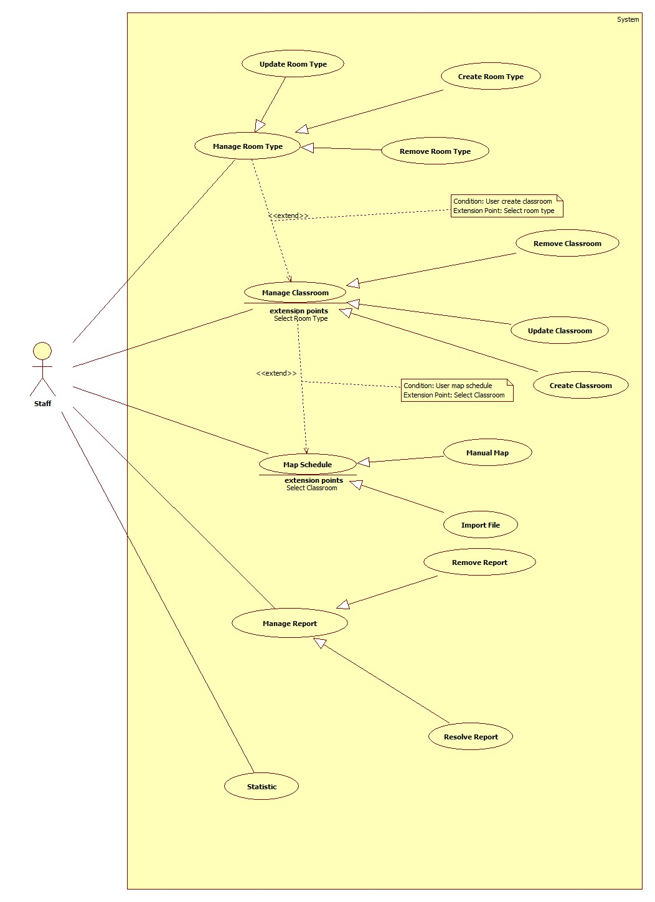

Figure 9: <Staff> Use case Overview

* + - 1. <Staff> Create New Room Type

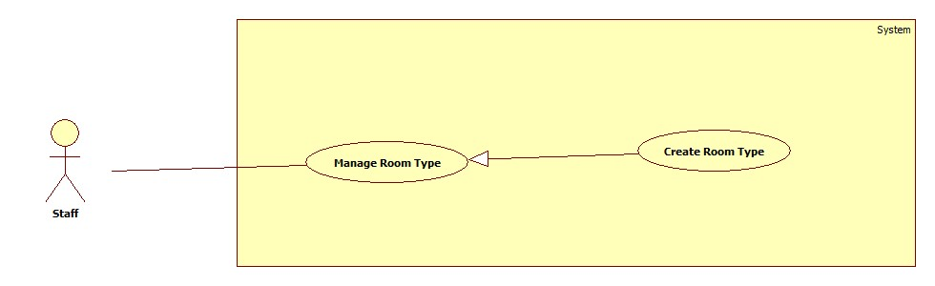

Figure 10: <Staff> Create Room Type

**Use case specification**

|  |  |  |  |
| --- | --- | --- | --- |
| **USE CASE – ECRM005** | |  |  |
| **Use Case No.** | ECRM005 | **Use Case Version** | 2.0 |
| **Use Case Name** | Create Room Type |  |  |
| **Author** | Tang Viet Hung |  |  |
| **Date** | 05/21/2015 | **Priority** | Normal |
| **Actor:** Staff | |  |  |
| **Summary:** This use case allows staff to create new room type.  **Goal:** Create room type to the system.  **Triggers:** Staff sends request “Tạo Kiểu Phòng” in “Kiểu Phòng” page.  **Preconditions:**   * User login as staff role.   **Post Conditions:**   * **Success:** New room type will be created and show successful message. * **Fail:** Unsuccessful message will be shown.   **Main Success Scenario:**   |  |  |  | | --- | --- | --- | | Step | Actor Action | System Response | | 1 | Staff focuses on “Phòng Học” and clicks “Kiểu Phòng”. | System navigates to “Kiểu Phòng” page. Page includes:   * Text box search. * Dropdown list: value list “Số kiểu”, “Số chỗ ngồi”. * Search: command. * Table with columns: * Số kiểu * Số chỗ ngồi * Check box * Xem: command. * Tạo mới: command   [Alternative 1, 2] | | 2 | Staff sends “Tạo Kiểu Phòng” request. | System navigates to “Tạo Mới Kiểu Phòng” page. Page includes:   * Số kiểu: textbox, disabled. * Máy lạnh: check box. * Máy chiếu: check box. * Tivi: check box. * Quạt: check box. * Loa: check box. * Số lượng dãy dọc: text box, number type, required. * Chấp nhận: command. * Cancel: command.   [Exception 1]  [Alternative 4] | | 3 | Staff inputs two textbox and sends “Chấp nhận” request. | System will show table with number of column equal with number staff inputted in “Số lượng dãy dọc”. Each column includes:   * Số dãy ngang: text box, number type, required. * Số chỗ ngồi mỗi dãy ngang: text box, number type, required. * Xem: command.   [Exception 2, 3, 4] | | 4 | Staff inputs all fields and sends “Xem” request. | System navigates to “Xem Kiểu Phòng” Page. Page includes:   * Classroom map. * Tạo Kiểu Phòng: command. * Cancel: command.   [Alternative 5] | | 5 | Staff sends “Tạo Kiểu Phòng” request. | System show successful message: “Tạo kiểu phòng mới thành công!” and navigate to “Kiểu Phòng” page. |     **Alternative Scenario:**     |  |  |  | | --- | --- | --- | | No | Actor Action | System Response | | 1 | Staff inputs to text box search and sends “Tìm kiếm” request. | Show result in table. | | 2 | Staff send request “Xem”. | Navigate to “Xem Kiểu Phòng” page. | | 4 | Staff sends “Cancel” request “Tạo Mới Kiểu Phòng” page. | System navigates to “Kiểu Phòng” page. | | 5 | Staff sends “Cancel” request “Xem Kiểu Phòng” page. | System navigates to “Tạo Mới Kiểu Phòng” page. |   **Exceptions:**   |  |  |  | | --- | --- | --- | | No | Actor Action | System Response | | 1 | “Số lượng dãy dọc” is empty or characters. | Show error message: “Số lượng dãy dọc không hợp lệ!” | | 2 | “Số chỗ ngồi mỗi dãy ngang” is empty or characters. | Show error message: “Số chỗ ngồi mỗi dãy ngang không hợp lệ!” | | 3 | Staff creates room type that has number of slots is more than 50 slots. | System show room map with only one chair and one table represent for the whole slots. | | 4 | Staff creates room type that has number of slots is 0. | Show error message: “Số lượng chỗ ngồi đủ để tạo kiểu phòng!” |   **Relationships:** N/A  **Business Rules:**   * System only support classroom with less than 50 slots. If it’s more than 50 slots, system will show room map with only one chair and one table represent for the whole slots. * “Số kiểu” is automatically generated by the system. It’s taken from database which is key. | | | |

Table 14: <Staff> Create Room Type

* + - 1. <Staff> Update Room Type

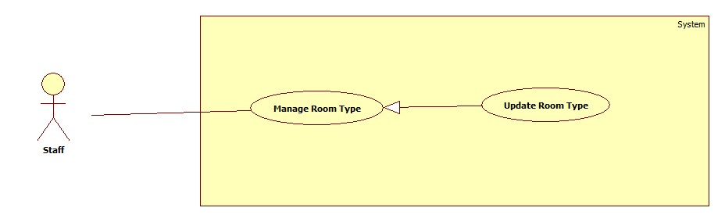

Figure 11: <Staff> Update Room Type

**Use case specification**

|  |  |  |  |
| --- | --- | --- | --- |
| **USE CASE – ECRM006** | |  |  |
| **Use Case No.** | ECRM006 | **Use Case Version** | 2.0 |
| **Use Case Name** | Update Room Type |  |  |
| **Author** | Tang Viet Hung |  |  |
| **Date** | 05/21/2015 | **Priority** | Normal |
| **Actor:** Staff | |  |  |
| **Summary:** This use case allows staff to update a room type.  **Goal:** Update a specific room type.  **Triggers:** Staff sends request “Chỉnh Sửa” on “Xem Kiểu Phòng” page.  **Preconditions:**   * User login as staff role. * Room type existed in database.   **Post Conditions:**   * **Success:** Room type will be updated and show successful message. * **Fail:** Unsuccessful message will be shown.   **Main Success Scenario:**   |  |  |  | | --- | --- | --- | | Step | Actor Action | System Response | | 1 | Staff focuses on “Phòng Học” and clicks “Kiểu Phòng”. | System navigates to “Kiểu Phòng” page. Page includes:   * Text box search. * Dropdown list. * Search: command. * Table with columns: * Số kiểu * Số chỗ ngồi * Check box * Xem: command. * Tạo mới: command   [Alternative 1, 2] | | 2 | Staff sends “Xem” request. | System navigates to “Xem Kiểu Phòng” page. Page includes:   * Sơ đồ kiểu phòng: map. * Xóa: command. * Chỉnh sửa: command. * Quay về: command.   [Alternative 3, 4] | | 3 | Staff sends “Chỉnh sửa” request. | System navigates to “Chỉnh Sửa Kiểu Phòng” page. Page includes:   * Số kiểu: textbox, disabled. * Máy lạnh: check box. * Máy chiếu: check box. * Tivi: check box. * Quạt: check box. * Loa: check box. * Số lượng dãy dọc: text box, number type, required. * Chấp nhận: command. * Cancel: command.   [Exception 1]  [Alternative 5] | | 4 | Staff inputs two textboxs and sends “Chấp nhận” request. | System will show table with number of column equal with number staff inputted in “Số lượng dãy dọc”. Each column includes:   * Số dãy ngang: text box, number type, required. * Số chỗ ngồi mỗi dãy ngang: text box, number type, required. * Xem: command.   [Exception 2, 3, 4] | | 4 | Staff inputs all fields and sends “Xem” request. | System navigates to “Xem Kiểu Phòng” Page. Page includes:   * Classroom map. * Tạo Kiểu Phòng: command. * Cancel: command. * [Alternative 6] | | 5 | Staff sends “Tạo Kiểu Phòng” request. | System show successful message: “Chỉnh sửa kiểu phòng thành công” and navigate to “Kiểu Phòng” page. |     **Alternative Scenario:**   |  |  |  | | --- | --- | --- | | No | Actor Action | System Response | | 1 | Staff inputs to text box search and sends “Tìm kiếm” request. | Show result in table. | | 2 | Staff sends “Xem” request. | Navigate to “Xem Kiểu Phòng” page. | | 3 | Staff sends “Xóa” request. | Show message: “Bạn có chắc muốn xóa kiểu phòng?” | |  | Staff sends “Quay về” request. | Naviages to “Kiểu Phòng” page. | | 5 | Staff sends “Cancel” request in “Chỉnh Sửa Kiểu Phòng” page. | System navigates to “Kiểu Phòng” page. | | 6 | Staff sends “Cancel” request in “Xem Kiểu Phòng” page. | System navigates to “Chỉnh Sửa Kiểu Phòng” page. |   **Exceptions:**   |  |  |  | | --- | --- | --- | | No | Actor Action | System Response | | 1 | “Số lượng dãy dọc” is empty or characters. | Show error message: “Số lượng dãy dọc không hợp lệ!” | | 2 | “Số chỗ ngồi mỗi dãy ngang” is empty or characters. | Show error message: “Số chỗ ngồi mỗi dãy ngang không hợp lệ!” | | 3 | Staff creates room type that has number of slots is more than 50 slots. | System show room map with only one chair and one table represent for the whole slots. | | 4 | Staff creates room type that has number of slots is 0. | Show error message: “Số lượng chỗ ngồi đủ để tạo kiểu phòng!” |   **Relationships:** N/A  **Business Rules:**   * System will automatically inputs all filed that existed on page “Chỉnh Sửa Kiểu Phòng”. It’s taken from database. * System only support classroom with less than 50 slots. If it’s more than 50 slots, system will show room map with only one chair and one table represent for the whole slots. * “Số kiểu” is automatically generated by the system. It’s taken from database which is key. | | | |

Table 15: <Staff> Update Room Type

* + - 1. <Staff> Remove Room Type

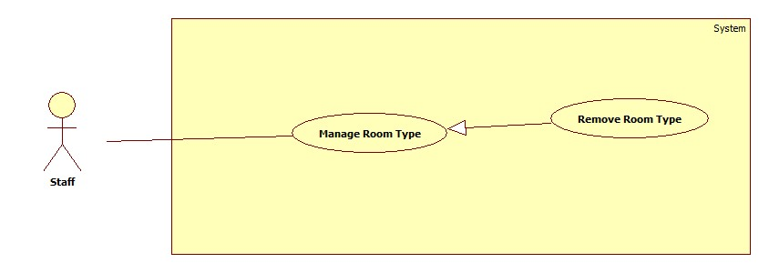

Figure 12: <Staff> Remove Room Type

**Use case specification**

|  |  |  |  |
| --- | --- | --- | --- |
| **USE CASE – ECRM007** | |  |  |
| **Use Case No.** | ECRM007 | **Use Case Version** | 2.0 |
| **Use Case Name** | Remove Room Type |  |  |
| **Author** | Tang Viet Hung |  |  |
| **Date** | 05/21/2015 | **Priority** | Normal |
| **Actor:** Staff | |  |  |
| **Summary:** This use case allows staff to delete a room type.  **Goal:** Delete a specific room type.  **Triggers:** Staff sends request “Xóa” in “Xem Kiểu Phòng” page.  **Preconditions:**   * User login as staff role. * Room type existed in database.   **Post Conditions:**   * **Success:** Room type will be deleted and show successful message. * **Fail:** Unsuccessful message will be shown.   **Main Success Scenario:**   |  |  |  | | --- | --- | --- | | Step | Actor Action | System Response | | 1 | Staff focuses on “Phòng Học” and clicks “Kiểu Phòng”. | System navigates to “Kiểu Phòng” page. Page includes:   * Text box search. * Dropdown list. * Search: command. * Table with columns: * Số kiểu * Số chỗ ngồi * Check box * Xem: command. * Tạo mới: command   [Alternative 1, 2] | | 2 | Staff sends “Xem” request. | System navigates to “Xem Kiểu Phòng” page. Page includes:   * Sơ đồ kiểu phòng: map. * Xóa: button. * Chỉnh sửa: command. * Quay về: command.   [Alternative 3, 4] | | 3 | Staff sends “Xóa” request. | Show dialog: “Bạn có chắc muốn xóa kiểu phòng?”  [Alternative 5] | | 4 | Staff clicks “Yes” button in dialog. | System shows successful message: “Xóa kiểu phòng thành công” and navigates to “Kiểu Phòng” page. |     **Alternative Scenario:**   |  |  |  | | --- | --- | --- | | No | Actor Action | System Response | | 1 | Staff inputs to text box search and sends “Tìm kiếm” request. | Show result in table. | | 2 | Staff sends “Tạo Mới” request. | Navigate to “Tạo Mới Kiểu Phòng” page. | | 3 | Staff sends “Sửa” request. | Navigate to “Chỉnh Sửa Kiểu Phòng” page. | |  | Staff sends “Quay về” request. | Naviages to “Kiểu Phòng” page | | 5 | Staff clicks “No” in dialog | System remains in “Xem Kiểu Phòng” Page. |   **Exceptions:** N/A  **Relationships:** N/A  **Business Rules:**   * After receiving request, system will delete room type in database and all the classroom that use this room type will be unable to view classroom map. | | | |

Table 16: <Staff> Remove Room Type

* + - 1. <Staff> Create Classroom

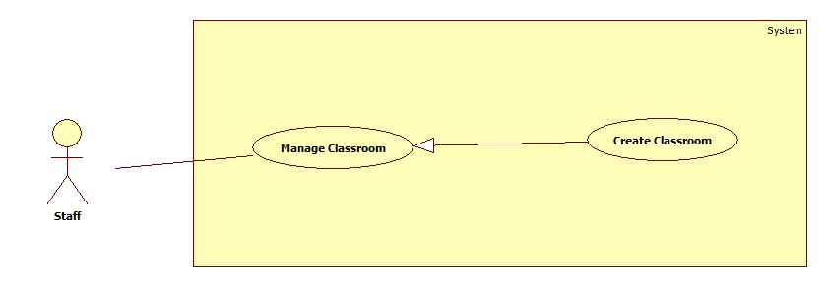

Figure 13: <Staff> Create Classroom

**Use case specification**

|  |  |  |  |
| --- | --- | --- | --- |
| **USE CASE – ECRM008** | |  |  |
| **Use Case No.** | ECRM008 | **Use Case Version** | 2.0 |
| **Use Case Name** | Create Classroom |  |  |
| **Author** | Tran Vinh Quang |  |  |
| **Date** | 05/21/2015 | **Priority** | Normal |
| **Actor:**   * Staff | |  |  |
| **Summary:**   * This use case allows staff to create new classroom (applied for web application)   **Goal:** Add new classroom to database  **Triggers:** Staff sends request “Thêm Lớp Học” in classroom management page.  **Preconditions:**   * User must login into the system with staff role.   **Post Conditions:**   * **Success:** New classroom will be added to database. Success message will be shown. * **Fail:** Error message will be shown.   **Main Success Scenario:**   |  |  |  | | --- | --- | --- | | Step | Actor Action | System Response | | 1 | Staff sends request “Thêm Lớp Học” in manage page. | System navigates to “Thêm Lớp Học” page.  Show form with the following information:   * Tên phòng: free text input, min length: 1, max length: 100, required. * Loại phòng: Value of list, required (Phòng 25 ghế, Phòng 30 ghế…) * Tạo mới: command * Hủy: command   [Alternative 1] | | 2 | Staff fills necessary information into the form |  | | 3 | Staff send “Tạo mới” request. | Classroom is added to database, success message “Thêm mới lớp học thành công” is shown.  System is navigation to “Classroom Management Page”.  [Exception 1,2,3] |     **Alternative Scenario:**   |  |  |  | | --- | --- | --- | | No | Actor Action | System Response | | 1 | Staff click “Hủy” | System navigation to “Classroom Management Page” |   **Exceptions:**   |  |  |  | | --- | --- | --- | | No | Cause | System Response | | 1 | “Tên phòng học” field is empty | Error message “Tên phòng học không được để trống!” is shown. | | 2 | “Tên phòng học” field data length is longer than 100 characters. | Error message “Tên phòng học không được quá 100 ký tự!” is shown. | | 3 | “Tên phòng học” field is duplicated in database | Error message “Phòng học có tên này đã được tạo, vui lòng sử dụng tên khác” is shown. |   **Relationships:** N/A  **Business Rules:**   * Each classroom will have only 1 type. * Button “Tạo mới” will enable when all of information have been filled. | | | |

Table 17: <Staff> Create Classroom

* + - 1. <Staff> Update Classroom

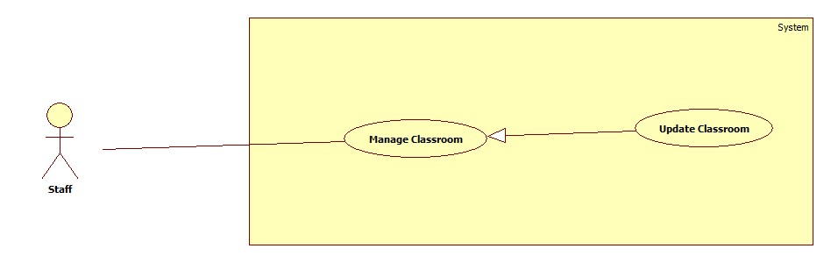

Figure 14: <Staff> Update Classroom

**Use case specification**

|  |  |  |  |
| --- | --- | --- | --- |
| **USE CASE – ECRM009** | |  |  |
| **Use Case No.** | ECRM009 | **Use Case Version** | 2.0 |
| **Use Case Name** | Update Classroom |  |  |
| **Author** | Tran Vinh Quang |  |  |
| **Date** | 05/21/2015 | **Priority** | Normal |
| **Actor:**   * Staff | |  |  |
| **Summary:**   * This use case allows staff to update information of classroom (applied for web application)   **Goal:** Update existed classroom.  **Triggers:** Staff sends “Sửa” command in classroom management page.  **Preconditions:**   * User must login into the system with staff role. * Classroom exists in database.   **Post Conditions:**   * **Success:** Classroom will be updated with new information. Success message will be shown. * **Fail:** Classroom will not be updated. Error message will be shown.   **Main Success Scenario:**   |  |  |  | | --- | --- | --- | | Step | Actor Action | System Response | | 1 | Staff choose classroom and sends request to update exist classroom. | System navigates to classroom detail page.  Show form with the following information:   * Tên phòng: Text input, min length: 1, max length: 100, required. * Loại phòng: List of value, required (Phòng 25 ghế, Phòng 30 ghế…) * Lưu: command * Hủy: command   [Alternative 1] | | 2 | Staff fills necessary information into the form |  | | 3 | Staff sends “Lưu” command. | Confirm dialog will be shown  [Exception 1,2,3]  [Alternative 1,] | | 4 | Staff click “Đồng ý” button | Classroom will be updated and show successful message. System navigation to Classroom Management Page |   **Alternative Scenario:**   |  |  |  | | --- | --- | --- | | No | Actor Action | System Response | | 1 | Staff click “Hủy” | Return to classroom management page. | | 1 | Staff click “Cancel” | Confirm dialog will be canceled and no change is made. |   **Exceptions:**   |  |  |  | | --- | --- | --- | | No | Cause | System Response | | 1 | “Tên phòng học” field is empty | Error message “Tên phòng học không được để trống!” is shown. | | 2 | “Tên phòng học” field data length is longer than 100 characters. | Error message “Tên phòng học không được quá 100 ký tự!” is shown. | | 3 | “Tên phòng học” field is duplicated in database | Error message “Phòng học có tên này đã được tạo, vui long sử dụng tên khác” is shown. |   **Relationships:** N/A  **Business Rules:**   * Staff can update name and type of classroom. | | | |

Table 18: <Staff> Update Classroom

* + - 1. <Staff> Remove Classroom

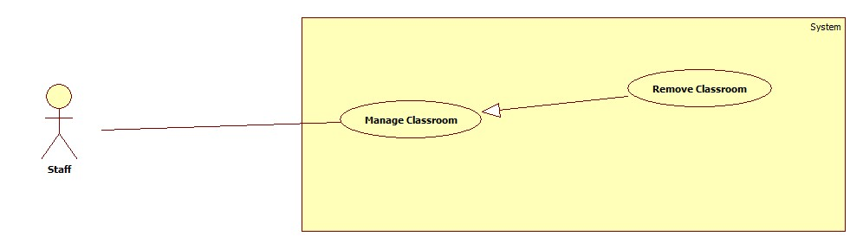

Figure 15: <Staff> Remove Classroom

**Use case specification**

|  |  |  |  |
| --- | --- | --- | --- |
| **USE CASE – ECRM010** | |  |  |
| **Use Case No.** | ECRM010 | **Use Case Version** | 2.0 |
| **Use Case Name** | Remove Classroom |  |  |
| **Author** | Tran Vinh Quang |  |  |
| **Date** | 05/21/2015 | **Priority** | Normal |
| **Actor:**   * Staff | |  |  |
| **Summary:**   * This use case allows staff to remove of classroom (applied for web application)   **Goal:** Remove existed classroom from system.  **Triggers:** Staff send “Xóa” request in classroom management page.  **Preconditions:**   * User must login into the system with staff role. * Classroom exists in database.   **Post Conditions:**   * **Success:** Classroom will be deleted from database. Success message will be shown. * **Fail:** Classroom will not be deleted. Error message will be shown.   **Main Success Scenario:**   |  |  |  | | --- | --- | --- | | Step | Actor Action | System Response | | 1 | Staff choose classroom and send request to delete classroom | System navigates to classroom detail page.  Show form with the following information:   * Tên phòng: Text input, min length: 1, max length: 100, required. disable * Loại phòng: Value of list, required (Phòng 25 ghế, Phòng 30 ghế…) disable * Xóa: command * Hủy: command   [Alternative 1] | | 2 | Staff send “Xóa” command | Confirm dialog will be shown [Exception 1,2,3,4,5,6,7]  [Alternative 1] | | 3 | Staff click “OK” | Classroom will be deleted and show successful message. System navigation to Classroom Management Page |   **Alternative Scenario:**   |  |  |  | | --- | --- | --- | | No | Cause | System Response | | 1 | Staff click “Cancel” | Confirm dialog will be canceled and no change is made. |   **Exceptions: N/A**  **Relationships:** N/A  **Business Rules:**   * After delete classroom, all of information about class such as damage equipment, type, and schedule will be deleted. | | | |

Table 19: <Staff> Remove Classroom

* + - 1. <Staff> Resolve Report

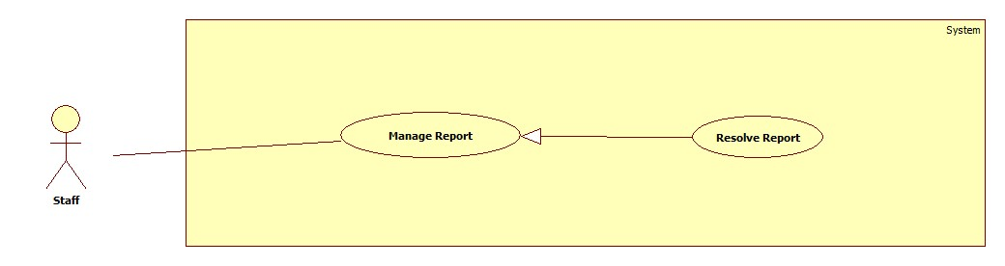

Figure 16: <Staff> Resolve Report

**Use case specification**

|  |  |  |  |
| --- | --- | --- | --- |
| **USE CASE – ECRM011** | | | |
| **Use Case No.** | ECRM011 | **Use Case Version** | 2.0 |
| **Use Case Name** | Resolve Report | | |
| **Author** | Doan Nguyen Minh Chi | | |
| **Date** | 05/21/2015 | **Priority** | High |
| **Actor:**   * Staff   **Summary:**   * This use case allows staff to resolve damaged equipment in report, or all of damaged equipment in room.   **Goal:**   * Report will be resolved, and user will receive notification.   **Triggers:**   * Staff sends request view new report notification.   **Preconditions:**   * User must be staff.   **Post Conditions:**   * **Success:** Report must be resolved and user receives resolved massage. * **Fail:** Show error message.   **Main Success Scenario:**   |  |  | | --- | --- | | Actor Action | System Response | | 1. Staff sends request view new notification. |  | |  | 1. System will show report detail of notify with two tab and some button:  * “Báo cáo” tab:   + “Phòng”: label   + “Người báo cáo”: label   + “Thời gian báo cáo”: label   + “Thiết bị”: label + “Vị trí” send command   + “Mức độ hư hại”: value ranges [0-100]   + “Mô tả từ giáo viên”: label   + “Đề nghị đổi phòng”: label + “Đổi phòng” send command * “Lịch sử” tab:   + “Thiết bị”: value list     - “Máy chiếu”     - “Máy lạnh”     - “Máy quạt”     - ……...   + Table history damaged of this equipment * “Khắc phục” send command * “Xóa” send command * “Xóa tất cả” send command * “Khắc phục tất cả” send command * “Thoát” send command | | 1. Staff sends “Khắc phục” request   [Alternative 1] [Alternative 2]  [Alternative 3] [Alternative 4] |  | |  | 1. System saves resolve data.   [Exception 1] |   **Alternative Scenario:**   |  |  |  | | --- | --- | --- | | No | Actor Action | System Response | | 1 | Staff sends “Xem bản đồ” request |  | |  | Show classroom map with position of damaged equipment | | 2 | 1. Staff sends “Đổi phòng” request |  | |  | 1. Show change room form with:  * “Phòng trống”: label * “Phòng khác”: send command * “Đổi” send command * “Thoát” send command | | 1. Staff sends “Đổi” request   [Alternative 5, 6] |  | |  | 1. Change to new room for class | | 3 | Staff chooses “Lịch sử” |  | |  | Show resolved history of equipment in room | | 4 | 1. Staff sends “Khắc phục tất cả” request |  | |  | 1. Show list all damaged equipment in this room.  * Equipment image: image   + Equipment name: label   + Number of damaged equipment. | | 1. Staff will chooses some damaged equipment |  | |  | 1. System saves resolved data. |   **Exceptions:**   |  |  |  | | --- | --- | --- | | No | Cause | System Response | | 1 | Staff sends “Khắc phục” request but the report has already resolved. |  | |  | Show message: “Báo cáo đã được xử lý bởi một nhân viên khác.” | | 2 | System cannot send SMS. |  | |  | System will resent at 10 minute later. |   **Relationships:**  **Business Rules:**   * SMS will be sent two times. * All damaged equipment always update when user report other equipment in this room. * If damaged level of room is higher than 35%, the system will show available rooms. * When staff resolves a report, it notifies for other staff. * Equipment in other report are fixed in report, it will update in other report. * Report’s status will change to “going” when all the damaged equipment was not fixed. A damaged equipment change to “finish” status after it was fixed. * Report’s status will be changed to “finish” when all damaged equipment was fixed. | | | |

Table 20: <Staff> Resolve Report

* + - 1. **<Staff> Remove Report**

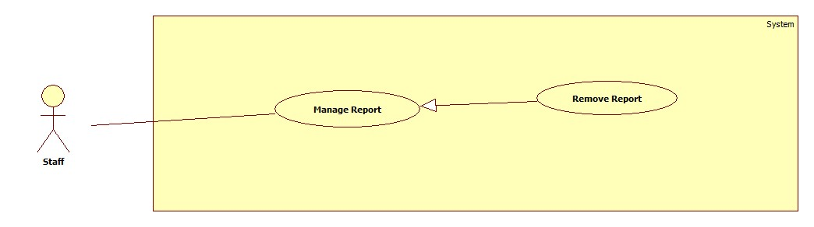

|  |  |  |  |
| --- | --- | --- | --- |
| **USE CASE – ECRM012** | | | |
| **Use Case No.** | ECRM012 | **Use Case Version** | 2.0 |
| **Use Case Name** | Remove Report | | |
| **Author** | Tran Vinh Quang | | |
| **Date** | 05/21/2015 | **Priority** | High |
| **Actor:**   * Staff   **Summary:**   * This use case allows staff to remove report   **Goal:**   * Report will be removed   **Triggers:**   * Staff sends request remove report   **Preconditions:**   * User must login to system with role staff.   **Post Conditions:**   * **Success:** Report must be removed. * **Fail:** Show error message.   **Main Success Scenario:**   |  |  | | --- | --- | | Actor Action | System Response | | Staff sends request view new notification. |  | |  | System will show report detail of notify with two tab and some button:   * “Báo cáo” tab:   + “Phòng”: label   + “Người báo cáo”: label   + “Thời gian báo cáo”: label   + “Thiết bị”: label + “Vị trí” send command   + “Mức độ hư hại”: value ranges [0-100]   + “Mô tả từ giáo viên”: label   + “Đề nghị đổi phòng”: label + “Đổi phòng” send command * “Lịch sử” tab:   + “Thiết bị”: value list     - “Máy chiếu”     - “Máy lạnh”     - “Máy quạt”     - ……...   + Table history damaged of this equipment * “Khắc phục” send command * “Xóa” send command. * “Xóa tất cả” send command * “Khắc phục tất cả” send command * “Thoát” send command | | Staff sends “Xóa” request |  | |  | System remove report  [Exception 1] |   **Alternative Scenario:**   |  |  |  | | --- | --- | --- | | No | Actor Action | System Response | | 1 | Staff sends “Xem bản đồ” request |  | |  | Show classroom map with position of damaged equipment | | 2 | Staff chooses “Lịch sử” |  | |  | Show resolved history of equipment in room | | 3 | Staff sends “Xóa tất cả” request |  | |  | Show list all damaged equipment in this room.   * Equipment image: image   + Equipment name: label   + Number of damaged equipment. | | Staff will chooses some damaged equipment |  | |  | System removed report had choose. |   **Exceptions:**   |  |  |  | | --- | --- | --- | | No | Cause | System Response | | 1 | Staff sends “Xóa” request but the report has not choose. |  | |  | Show message: “Bạn phải chọn 1 report mới thực hiện chức năng này.” | | 2 | System cannot send SMS. |  | |  | System will resent at 10 minute later. |   **Relationships:**  **Business Rules:**   * SMS will be sent two times. * All damaged equipment always update when user report other equipment in this room. * When staff removes a report, it notifies for other staff. * Report’s status will change to “remove” after complete this function. | | | |

Table 21: <Staff> Remove Report

* + - 1. <Staff> View Statistic

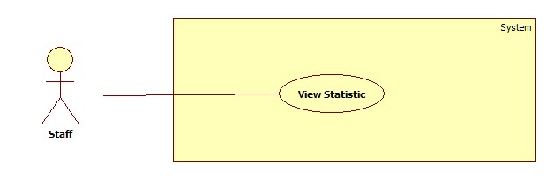

Figure 17: <Staff> View Statistic

**Use case specification**

* + - 1. <Staff> Mapping Schedule Manual

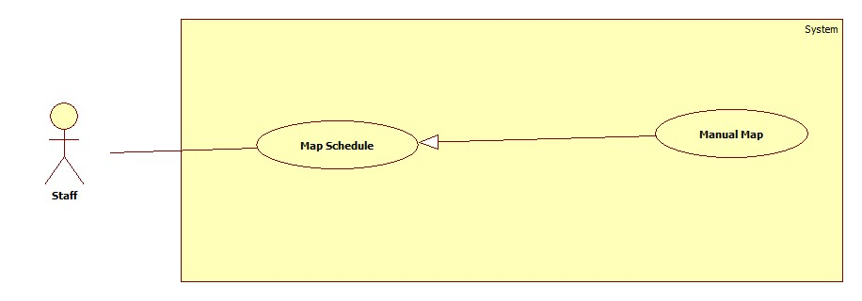

Figure 18: <Staff> Mapping Schedule Manual

**Use case specification**

|  |  |  |  |
| --- | --- | --- | --- |
| **USE CASE – ECRM014** | |  |  |
| **Use Case No.** | ECRM014 | **Use Case Version** | 2.0 |
| **Use Case Name** | Mapping Schedule Manual |  |  |
| **Author** | Tang Viet Hung |  |  |
| **Date** | 21/05/2015 | **Priority** | Normal |
| **Actor:** Staff | |  |  |
| **Summary:** This use case allows staff to import file schedule.  **Goal:** Import a schedule file.  **Triggers:** Staff sends “Manual” request on “Nhập Lịch” page.  **Preconditions:**   * User login as staff role.   **Post Conditions:**   * **Success:** Schedule file will be imported and show successful message. * **Fail:** Unsuccessful message will be shown.   **Main Success Scenario:**   |  |  |  | | --- | --- | --- | | Step | Actor Action | System Response | | 1 | Staff focuses on “Lịch” and clicks “Nhập Lịch”. | System navigates to “Nhập Lịch” page. Page includes:   * Nhập tay: command. * Tìm: command. * Tải template: command * Import: command.   [Alternative 1] | | 2 | Staff sends “Nhập tay” request. | System navigates to “Nhập Tay” page. Page includes form:   * Giáo viên: text input, min length: 6, max length: 30, required. * Giờ dạy bắt đầu: text input, time type, required. * Giờ dạy kết thúc: text input, time type, required. * Ngày dạy bắt đầu: text input, date type, required. * Ngày dạy kết thúc: text input, date type, required. * Số lượng học sinh: text input, number type, required. * Tên phòng: dropdown list, required. * Import: command. * Cancel: command.   [Exception 1, 2, 3, 4 ,5, 6] | | 3 | Staff inputs: “Giáo viên”, “Giờ dạy bắt đầu”, “Giờ dạy kết thúc”, “Ngày dạy bắt đầu”, “Ngày dạy kết thúc”, “”Number of student”. | System will add data into “Tên phòng” dropdown list.  [Exception 7, 8] | | 4 | Staff sends “Import” request.  [Alternative 1] | System shows successful message. |     **Alternative Scenario:**   |  |  |  | | --- | --- | --- | | No | Actor Action | System Response | | 1 | Staff sends “Cancel” request. | System navigates to “Nhập Lịch” page |   **Exceptions:**   |  |  |  | | --- | --- | --- | | No | Actor Action | System Response | | 1 | “Giáo viên” text input is empty or not in range. | System shows error message: “Giáo viên phải từ 6 tới 30 ký tự. Vui lòng thử lại!” | | 2 | “Giờ dạy bắt đầu” text input is empty or not time type. | System shows error message: “Giờ dạy bắt đầu không hợp lệ. Vui lòng thử lại!” | | 3 | “Giờ dạy kết thúc” text input is empty or not time type. | System shows error message: “Giờ dạy kết thúc không hợp lệ. Vui lòng thử lại!” | | 4 | “Ngày dạy bắt đầu” text input is empty or not time type. | System shows error message: “Ngày dạy bắt đầu không hợp lệ. Vui lòng thử lại!” | | 5 | “Ngày dạy kết thúc” text input is empty or not time type. | System shows error message: “Ngày dạy kết thúc” không hợp lệ. Vui lòng thử lại!” | | 6 | System could not show any data. | System shows error message: “Không tìm thấy phòng học phù hợp. Vui lòng thử lại!” | | 6 | “Tên phòng” is not selected. | System shows error message: “Phải chọn một lớp học. Vui lòng thử lại!” |   **Relationships:** N/A  **Business Rules:**   * **“**Tên phòng**”** will appear after staff inputted all the text input above. * In manual function, after inputting all the field, system will check in database that if any classroom are appropriate with data that staff inputted. System will allow staff to import schedule if and only if there are classroom available. | | | |

Table 22: <Staff> Mapping Schedule Manual

* + - 1. <Staff> Mapping Schedule Import File

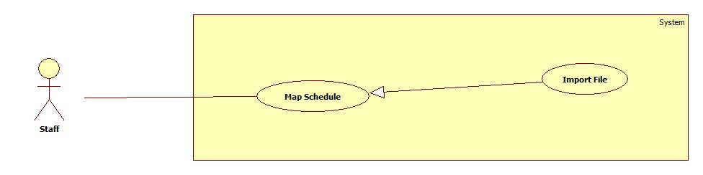

Figure 19: <Staff> Mapping Schedule Import File

Use case specification

|  |  |  |  |
| --- | --- | --- | --- |
| **USE CASE – ECRM015** | |  |  |
| **Use Case No.** | ECRM015 | **Use Case Version** | 2.0 |
| **Use Case Name** | Import File |  |  |
| **Author** | Tang Viet Hung |  |  |
| **Date** | 21/05/2015 | **Priority** | Normal |
| **Actor:** Staff | |  |  |
| **Summary:** This use case allows staff to import file schedule.  **Goal:** Import a schedule file.  **Triggers:** Staff sends “Import” request on “Nhập Lịch” page.  **Preconditions:**   * User login as staff role.   **Post Conditions:**   * **Success:** Schedule file will be imported and show successful message. * **Fail:** Unsuccessful message will be shown.   **Main Success Scenario:**   |  |  |  | | --- | --- | --- | | Step | Actor Action | System Response | | 1 | Staff focuses on “Lịch” and clicks “Nhập Lịch”. | System navigates to “Nhập Lịch” page. Page includes:   * Tìm: command. * Tải template: command * Import: command.   [Alternative 1] | | 2 | Staff clicks on “Tìm” button and choose schedule excel file from his computer. | System shows the name of schedule file. | | 4 | Staff clicks “Import” button. | System shows successful message.  [Exception 1] |     **Alternative Scenario:**   |  |  |  | | --- | --- | --- | | No | Actor Action | System Response | | 1 | Staff sends “Tải template” request. | Staff will get template excel file from server. |   **Exceptions:**   |  |  |  | | --- | --- | --- | | No | Actor Action | System Response | | 1 | Staff import a wrong template excel file. | System shows error message. |   **Relationships:** N/A  **Business Rules:**   * After receiving request, system will check validate the file that got from user. If it’s incorrect template, system will show error. The new schedule will be saved in database and system will delete the old one. | | | |

Table 23: <Staff> Mapping Schedule Import File

* + - 1. **<Authorized User> Use case overview**

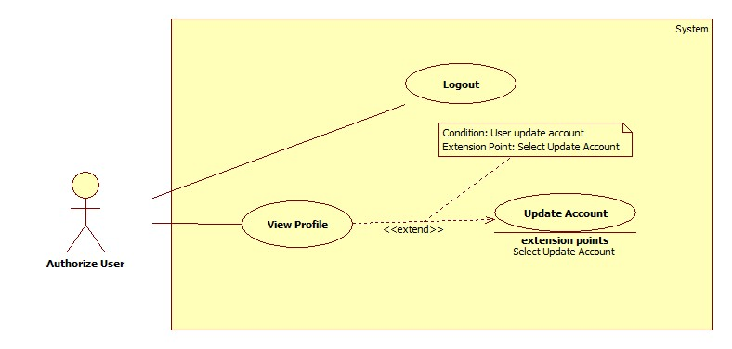

* + - 1. <Authorized User> Logout

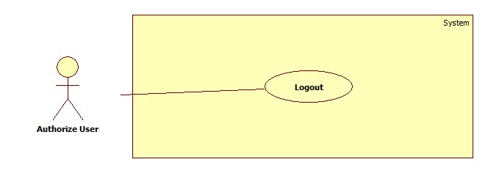

Figure 20: <Authorized User> Logout

**Use case specification**

|  |  |  |  |
| --- | --- | --- | --- |
| **USE CASE – ECRM016** | |  |  |
| **Use Case No.** | ECRM016 | **Use Case Version** | 2.0 |
| **Use Case Name** | Logout |  |  |
| **Author** | Tang Viet Hung |  |  |
| **Date** | 05/21/2015 | **Priority** | Normal |
| **Actor:** Guest | |  |  |
| **Summary:** This use case allows user to logout.  **Goal:** Logout of the system  **Triggers:** User click on “Logout” button  **Preconditions:**   * User has successfully logged in system.   **Post Conditions:**   * **Success:** User will be logged out of system. * **Fail:** Unsuccessful message will be shown.   **Main Success Scenario:**   |  |  |  | | --- | --- | --- | | Step | Actor Action | System Response | | 1 | User send “Đăng xuất” request. | System show dialog: “Bạn có chắc muốn đăng xuất?” | | 2 | User clicks “Yes” button. | System navigates to login screen. |     **Alternative Scenario:**     |  |  |  | | --- | --- | --- | | Step | Actor Action | System Response | | 1 | User clicks “No” button in dialog. | System remains user in current page. |   **Exceptions:** N/A    **Relationships:** N/A  **Business Rules:**   * After logout successfully, guest cannot use the system. | | | |

Table 24: <Authorized User> Logout

* + - 1. **<Authorized User> View Profile**

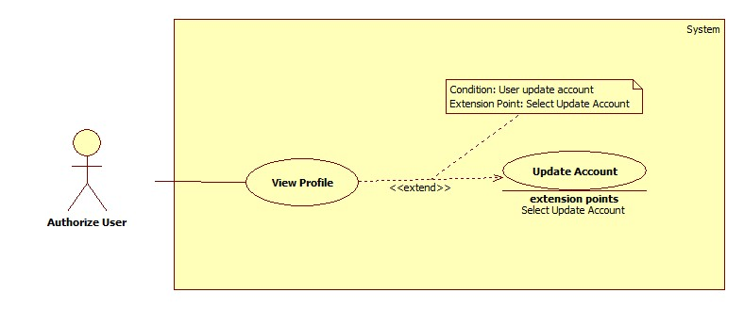

Figure 21: <Authorized User> View Profile

**Use case specification.**

|  |  |  |  |
| --- | --- | --- | --- |
| **USE CASE – ECRM017** | |  |  |
| **Use Case No.** | ECRM017 | **Use Case Version** | 2.0 |
| **Use Case Name** | View Profile |  |  |
| **Author** | Tran Vinh Quang |  |  |
| **Date** | 05/21/2015 | **Priority** | Normal |
| **Actor:** User | |  |  |
| **Summary:** This use case allows user to view all information of their account.  **Goal:** View information of account.  **Triggers:** User clicks on account name link.  **Preconditions:**   * User has successfully logged in system.   **Post Conditions:**   * **Success:** User will be see all of information of their account * **Fail:** Unsuccessful message will be shown.   **Main Success Scenario:**   |  |  |  | | --- | --- | --- | | Step | Actor Action | System Response | | 1 | User view account’s information by send request to get profile. | System navigates to profile page.  It contains the following information:   * Username: Label * Họ Tên: Text input * “Số Điện Thoại”: Text input * “Trạng thái”: Label * “Cập nhật”: command * “Thay đổi Password”: command.   [Exception 1] |     **Alternative Scenario:** N/A  **Exceptions:**     |  |  |  | | --- | --- | --- | | Step | Cause | System Response | | 1 | Connection error | Show error message: “Lỗi kết nối, vui lòng tải lại” |   **Relationships:** extend Update Account  **Business Rules:**   * From Profile Page, User can change their password, update new phone number and update real name. * User can edit text “Số Điện Thoại” and send “Cập nhật” command to update new phone number. * User can edit text “Họ Tên” and send “Cập nhật” command to update new real name | | | |

Table 25: <Authorized User> View Profile

* + - 1. <Authorized User> Update Account



Figure 22: <Authorized User> Update Account

**Use case specification**

|  |  |  |  |
| --- | --- | --- | --- |
| **USE CASE – ECRM018** | |  |  |
| **Use Case No.** | ECRM018 | **Use Case Version** | 2.0 |
| **Use Case Name** | Update Account |  |  |
| **Author** | Tran Vinh Quang |  |  |
| **Date** | 05/21/2015 | **Priority** | Normal |
| **Actor:** User | |  |  |
| **Summary:** This use case allows user to change password of their account.  **Goal:** Change password of account.  **Triggers:** User send “Cập nhật Password” request in Profile page.  **Preconditions:**   * User has successfully logged in system.   **Post Conditions:**   * **Success:** User will be changed their password, show successful message. * **Fail:** Unsuccessful message will be shown.   **Main Success Scenario:**   |  |  |  | | --- | --- | --- | | Step | Actor Action | System Response | | 1 | User send “Change Password” request in Profile page. | System navigates to “Change Password” page.  It contains form with the following information:   * Current Password: Text input, type: Password * New Password: Text input, min length: 6, max length: 20, type: Password, required. * Confirm Password: Text input, min length: 6, max length: 20, type: Password, required. * “Thay đổi”: command | | 2 | User fills information into the form and send “Thay đổi” request. | System show successful message and redirect to Profile page.  [Exception 1, 2, 3,4,5] |     **Alternative Scenario:** N/A  **Exceptions:**     |  |  |  | | --- | --- | --- | | Step | Cause | System Response | | 1 | Connection error | Show error message: “Lỗi kết nối, vui lòng tải lại” | | 2 | Current password field is wrong | Show error message: “Sai password hiện tại, vui lòng nhập lại” | | 3 | New password and confirm password are not match | Show error message: “New Password and Confirm password không giống nhau, vui lòng nhập lại” | | 4 | New password and confirm password field data length is longer than 20 character or lower than 6 character. | Show error message: “Password phải nằm trong khoản từ 6 đến 20 ký tự” | | 5 | New password is same with current password | Show error message: “Mật khẩu mới phải khác mật khẩu hiện tại” |   **Relationships:** N/A  **Business Rules:**   * If the first time user login to system, they will be redirect to “Change Password” page. * New password does not same with current password. | | | |

Table 26: <Authorized User> Update Account

* + - 1. **<Administrator> Use case Overview**

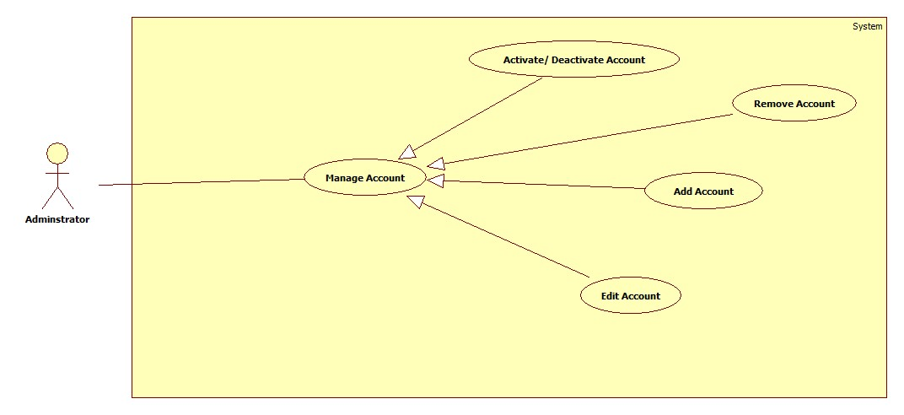

* + - 1. **< Administrator> Add Account**

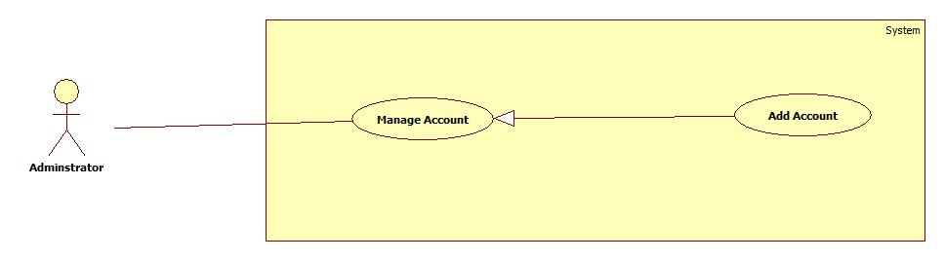

Figure 23: <Administrator> Add Account

**Use case specification**

|  |  |  |  |
| --- | --- | --- | --- |
| **USE CASE – ECRM019** | |  |  |
| **Use Case No.** | ECRM019 | **Use Case Version** | 2.0 |
| **Use Case Name** | Add Account |  |  |
| **Author** | Tang Viet Hung |  |  |
| **Date** | 21/05/2015 | **Priority** | Normal |
| **Actor:** Staff | |  |  |
| **Summary:** This use case allows staff to add new account.  **Goal:** Add new account to the system.  **Triggers:** Staff wants to add new account.  **Preconditions:**   * User login as staff role.   **Post Conditions:**   * **Success:** New account will be created and show successful message. * **Fail:** Unsuccessful message will be shown.   **Main Success Scenario:**   |  |  |  | | --- | --- | --- | | Step | Actor Action | System Response | | 1 | Staff focuses on “Account” and clicks “Tạo Tài Khoản” | System navigates to “Tạo Tài Khoản” page. Page includes form:   * Username: text input, min length: 6, max length: 30, required. * Password: text input, min length: 6, max length: 20, required * Họ tên: text input, min length: 6, max length: 50, required. * Số điện thoại: text input, min length: 10, max length: 11, type: number, required. * Chức vụ: list value: “User”, “Staff”, required. * Clear: command. * Tạo tài khoản: command   [Alternative 1] | | 2 | Staff enters information and then sends “Tạo tài khoản” request. | Create new account and show successful message: “Tài khoản được tạo thành công”.[Exception 1, 2, 3, 4, 5, 6] |     **Alternative Scenario:**   |  |  |  | | --- | --- | --- | | No | Actor Action | System Response | | 1 | Staff sends Clear request. |  | |  | System will reset all data had inputted. |       **Exceptions:**   |  |  |  | | --- | --- | --- | | No | Actor Action | System Response | | 1 | Length of “username” is not in range. | Show unsuccessful message: “Username bao gồm từ 6 đến 10 ký tự. Xin thử lại!” | | 2 | “Số điện thoại” is empty or contain characters. | Show unsuccessful message: “Số điện thoại không hợp lệ. Xin thử lại!” | | 3 | “Họ tên” is empty. | Show unsuccessful message: “Họ tên không được bỏ trống. Xin thử lại!” | | 4 | “Username” have been already existed. | Show unsuccessful message: “Username đã tồn tại, vui lòng nhập lại!” | | 5 | “Số điện thoại” field data length is not in range | Show unsuccessful message: “Số điện thoại không hợp lệ. Xin thử lại!” | | 6 | “Password” field data length is not in range | Show unsuccessful message: “Password không hợp lệ. Xin thử lại!” |     **Relationships:** N/A  **Business Rules:**   * Account is created with active status. * “Số điện thoại” field data must start by “0”. * Staff only creates account with role user. * Admin can create account with role user or staff. | | | |

Table 27: <Administrator> Add New Account

* + - 1. <Administrator> Activate/Deactivate Account

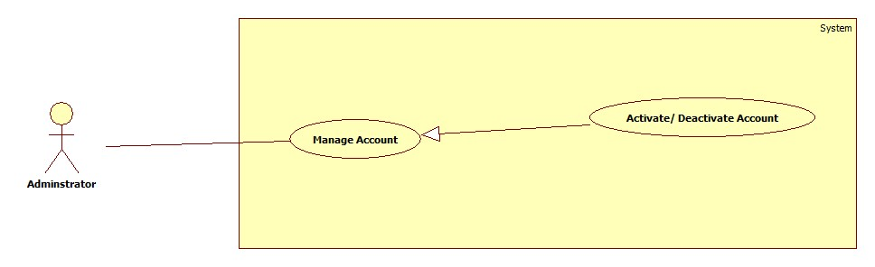

Figure 24: <Administrator> Activate/Deactivate Account

**Use case specification**

|  |  |  |  |
| --- | --- | --- | --- |
| **USE CASE – ECRM020** | |  |  |
| **Use Case No.** | ECRM020 | **Use Case Version** | 2.0 |
| **Use Case Name** | Activate/ Deactivate Account |  |  |
| **Author** | Tang Viet Hung |  |  |
| **Date** | 21/05/2015 | **Priority** | Normal |
| **Actor:** Staff | |  |  |
| **Summary:** This use case allows staff to activate and deactivate user’s account in system.  **Goal:** Activate and deactivate user’s account  **Triggers:** Staff wants to activate or deactivate user’s account.  **Preconditions:**   * User must login with staff role.   **Post Conditions:**   * **Success:** user’s account will be changed its status to Activated or Deactivated and show successful message. * **Fail:** Unsuccessful message will be shown.   **Main Success Scenario:**   |  |  |  | | --- | --- | --- | | Step | Actor Action | System Response | | 1 | Staff focuses on “Account” and clicks “Edit Account” | System navigates to “Manage Account” page.   * Table contains columns:   + - Username.     - Classroom: teacher’s classroom.     - Check box. * Activate: command. * Deactivate: command. | | 2 | Staff selects account that they want to activate or deactivate. |  | | 3 | Staff sends “Activate” or “Deactivate” request. | Update status of account and show successful message: “Cập nhật tài khoản thành công!”  [Exception 1] |     **Alternative Scenario:** N/A    **Exceptions:**     |  |  |  | | --- | --- | --- | | No | Actor Action | System Response | | 1 | Staff didn’t select any check box and then clicks “Activate” or “Deactivate” button | Show error message: “Vui lòng chọn ít nhất một tài khoản!” |   **Relationships:** N/A  **Business Rules:**   * After receiving request, system will change user’s status to “Activated” or “Deactivated”. * Only activated user can login to the system. | | | |

Table 28: <Administrator> Activate/Deactivate Account

* + - 1. <Administrator> Update Account

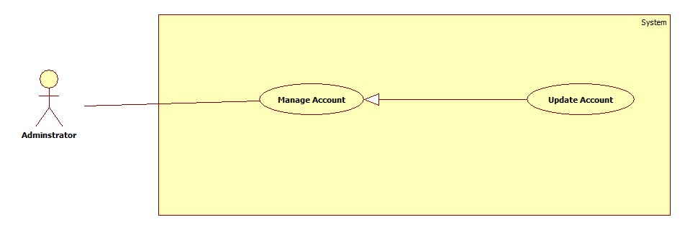

Figure 25: <Administrator> Update Account

**Use case specification**

|  |  |  |  |
| --- | --- | --- | --- |
| **USE CASE – ECRM021** | |  |  |
| **Use Case No.** | ECRM021 | **Use Case Version** | 2.0 |
| **Use Case Name** | Update Account |  |  |
| **Author** | Tran Vinh Quang |  |  |
| **Date** | 05/21/2015 | **Priority** | Normal |
| **Actor:** User | |  |  |
| **Summary:** This use case allows user to change information includes password, real-name, phone number, role of account.  **Goal:** Change information includes password, real-name, phone number, role of account.  **Triggers:** Staff clicks on “Account” link in Account manage page.  **Preconditions:**   * Staff has successfully logged in system.   **Post Conditions:**   * **Success:** Account will be changed information, show successful message. * **Fail:** Unsuccessful message will be shown.   **Main Success Scenario:**   |  |  |  | | --- | --- | --- | | Step | Actor Action | System Response | | 1 | Staff clicks “Account” link. | System navigates to “Update Account” page.  It contains form with the following information:   * Username: textbox, min length: 6, max length: 30, required. * Password: textbox, min length: 6, max length: 20, required * Họ tên: textbox, min length: 6, max length: 50, required. * Số điện thoại: textbox, min length: 10, max length: 11, type: number, required. * Chức vụ: dropdown list, required. * Thay đổi: button | | 2 | User fills information into the form and sends “Thay đổi” request. | System show successful message and redirect to Profile page.  [Exception 1, 2, 3, 4, 5, 6] |     **Alternative Scenario:** N/A  **Exceptions:**     |  |  |  | | --- | --- | --- | | No | Actor Action | System Response | | 1 | Length of “username” is not in range. | Show unsuccessful message: “Username bao gồm từ 6 đến 10 ký tự. Xin thử lại!” | | 2 | “Số điện thoại” is empty or contain characters. | Show unsuccessful message: “Số điện thoại không hợp lệ. Xin thử lại!” | | 3 | “Họ tên” is empty. | Show unsuccessful message: “Họ tên không được bỏ trống. Xin thử lại!” | | 4 | “Username” have been already existed. | Show unsuccessful message: “Username đã tồn tại, vui lòng nhập lại!” | | 5 | “Số điện thoại” field data lenth is not in range | Show unsuccessful message: “Số điện thoại không hợp lệ. Xin thử lại!” | | 6 | “Password” field data length is not in range | Show unsuccessful message: “Password không hợp lệ. Xin thử lại!” |   **Relationships:** N/A  **Business Rules:**   * Staff only update information of user * Admin can update information of staff and user. | | | |

Table 29: <Administrator> Update Account

* + - 1. **<Administrator> Remove Account**

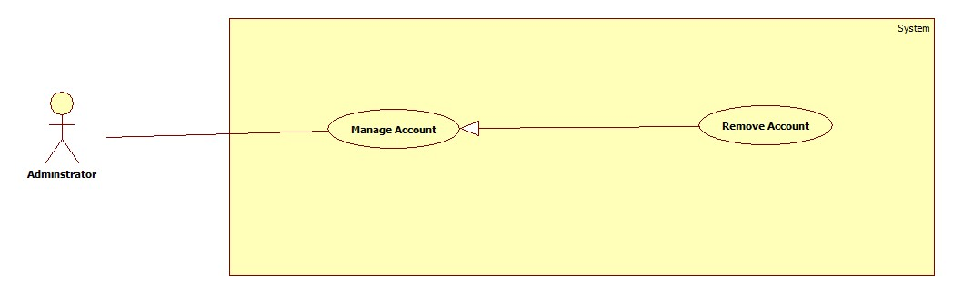

Figure 26: <Administrator> Remove Account

**Use case specification**

|  |  |  |  |
| --- | --- | --- | --- |
| **USE CASE – ECRM022** | |  |  |
| **Use Case No.** | ECRM022 | **Use Case Version** | 2.0 |
| **Use Case Name** | Remove Account |  |  |
| **Author** | Tang Viet Hung |  |  |
| **Date** | 21/05/2015 | **Priority** | Normal |
| **Actor:** Staff | |  |  |
| **Summary:** This use case allows administrator to remove user’s account in system.  **Goal:** Remove user’s account  **Triggers:** Administrator wants to remove user’s account.  **Preconditions:**   * User must login with administrator role.   **Post Conditions:**   * **Success:** user’s account will be remove from system and show successful message. * **Fail:** Unsuccessful message will be shown.   **Main Success Scenario:**   |  |  |  | | --- | --- | --- | | Step | Actor Action | System Response | | 1 | Administrator focuses on “Account” | System navigates to “Manage Account” page.   * Table contains columns:   + - Username.     - Classroom: teacher’s classroom.     - Check box. * Remove: command | | 2 | Administrator selects account that they want to remove |  | | 3 | Administrator sends “remove” request. | Update status of account and show successful message: “Xóa tài khoản thành công!”  [Exception 1] |     **Alternative Scenario:** N/A    **Exceptions:**     |  |  |  | | --- | --- | --- | | No | Actor Action | System Response | | 1 | Staff didn’t select any check box and then send “Remove” command | Show error message: “Vui lòng chọn ít nhất một tài khoản!” |   **Relationships:** N/A  **Business Rules:**   * After receiving request, system will change user’s status to “removed” * Only activated user can login to the system. | | | |

Table 30: <Administrator> Remove Account

* + - 1. **<System> Use case Overview**

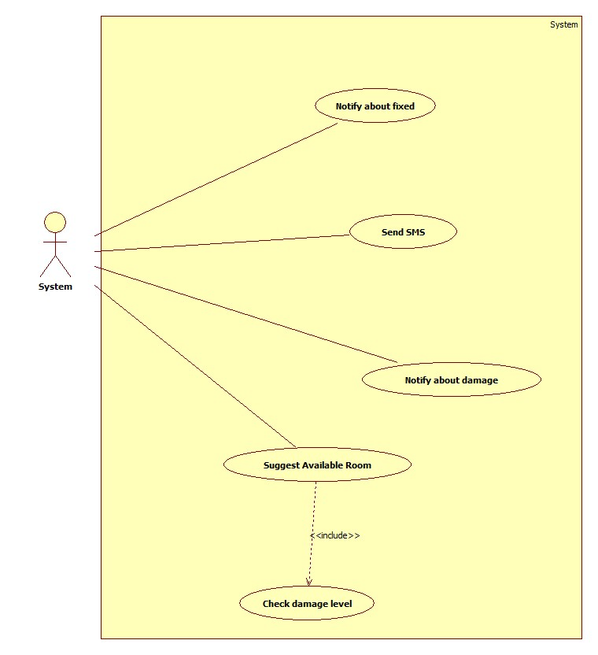

Figure 27: <System> Use case Overview

* + - 1. **<System> Notify about fixed**

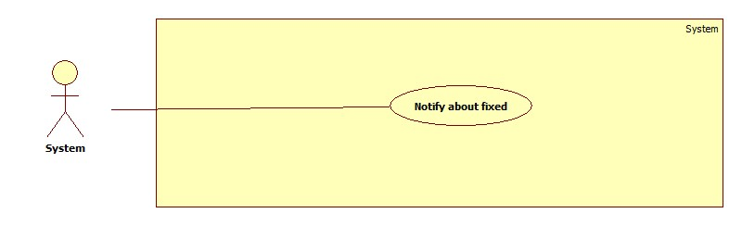

Figure 28: <System> Notify about fixed

**Use case specification**

|  |  |  |  |
| --- | --- | --- | --- |
| USE CASE – ECRM023 | | | |
| Use Case No. | ECRM023 | **Use Case Version** | 2.0 |
| Use Case Name | Notify about fixed | | |
| Author | Tran Vinh Quang | | |
| Date | 21/05/2015 | **Priority** | Medium |
| Actor:   * System   Summary:   * This use case describes how the system notifies to users when necessary.   Goal:   * System will send notification to users.   Triggers:   * System run a timer task that trigger check event.   Preconditions:   * Their must be at least one report has resolved in the system.   Post Conditions:   * Success: Show the status of report and notify to user. * Fail: System display error message.   Main Success Scenario:   |  |  |  | | --- | --- | --- | | Step | Actor Action | System Response | | 1 | System run timer task to check report state and sends notify | System response:   * Notifications that need to be sent to users.   [Exception 1] |   Exceptions:   |  |  |  | | --- | --- | --- | | No | Actor Action | System Response | | 1 | System timer task is interrupted | No notification will be sent. Error detail will be tracked in a log file. |   Relationships: N/A  Business rules:   * System will send notify after report has resolved. | | | |

Table 31: <System> Notify about fixed

* + - 1. **<System> Send SMS**

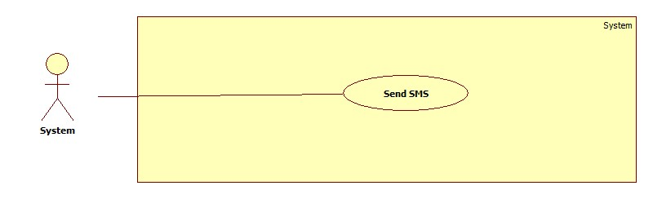

Figure 29: <System> Send SMS

**Use case specification**

|  |  |  |  |
| --- | --- | --- | --- |
| USE CASE – ECRM024 | | | |
| Use Case No. | ECRM024 | **Use Case Version** | 2.0 |
| Use Case Name | Send SMS | | |
| Author | Tran Vinh Quang | | |
| Date | 21/05/2015 | **Priority** | Medium |
| Actor:   * System   Summary:   * This use case describes how the system send SMS to users when necessary.   Goal:   * System will send SMS to users.   Triggers:   * System run a timer task that trigger check event.   Preconditions:   * Their must be at least one report has resolved in the system.   Post Conditions:   * Success: Show the status of report and notify to user. * Fail: System display error message.   Main Success Scenario:   |  |  |  | | --- | --- | --- | | Step | Actor Action | System Response | | 1 | System run timer task to check report state and sends SMS | System response:   * SMS that need to be sent to users.   [Exception 1] |   Exceptions:   |  |  |  | | --- | --- | --- | | No | Actor Action | System Response | | 1 | System timer task is interrupted | No notification will be sent. Error detail will be tracked in a log file. |   Relationships: N/A  Business rules:   * System will send SMS after report has resolved by changing room. * SMS will send to security and teacher. | | | |

Table 32: <System> Send SMS

* + - 1. **<System> Suggest Available Room**

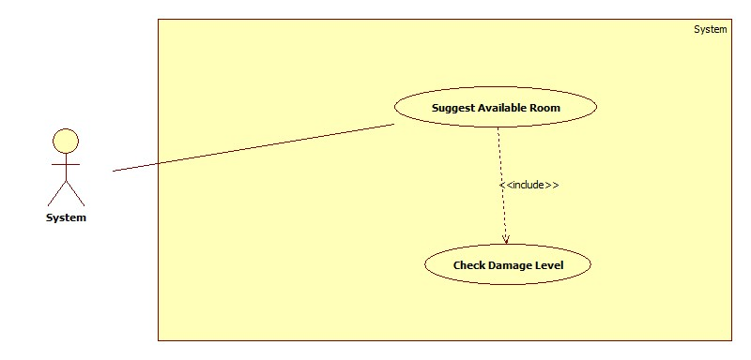

Figure 30: <System> Suggest Available Room

**Use case specification**

|  |  |  |  |
| --- | --- | --- | --- |
| USE CASE – ECRM024 | | | |
| Use Case No. | ECRM024 | **Use Case Version** | 2.0 |
| Use Case Name | Sugges Available Room | | |
| Author | Tran Vinh Quang | | |
| Date | 21/05/2015 | **Priority** | Medium |
| Actor:   * System   Summary:   * This use case describes how the system suggests room to staff when necessary.   Goal:   * System will automatic check damage level and suggest room if necessary.   Triggers:   * System run a timer task that trigger check event.   Preconditions:   * Their must be at least one report has sent in the system.   Post Conditions:   * Success: Show the status of report and notify to user. * Fail: System display error message.   Main Success Scenario:   |  |  |  | | --- | --- | --- | | Step | Actor Action | System Response | | 1 | System run timer task to check damaged level. | System response:   * Damage level of report * System suggest available room if necessary   [Exception 1] | | 2 |  |  |   Exceptions:   |  |  |  | | --- | --- | --- | | No | Actor Action | System Response | | 1 | System timer task is interrupted | No notification will be sent. Error detail will be tracked in a log file. |   Relationships: include Check damage level  Business rules:   * If damaged level is larger than 50%, system will automatic suggest available room * If damaged level is less than 10%, system will notify user after they send report. | | | |

Table 33: <System> Suggest Available Room

* + - 1. **<System> Notify about damaged**

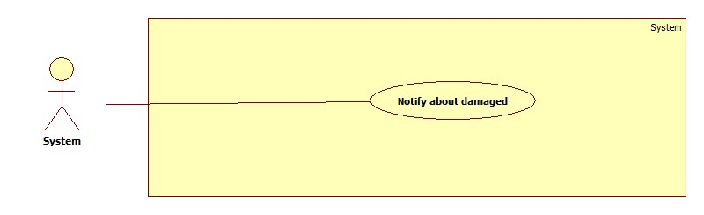

Figure 31: <System> Notify about damaged

**Use case specification**

|  |  |  |  |
| --- | --- | --- | --- |
| USE CASE – ECRM025 | | | |
| Use Case No. | ECRM025 | **Use Case Version** | 2.0 |
| Use Case Name | Notify about damaged | | |
| Author | Tran Vinh Quang | | |
| Date | 21/05/2015 | **Priority** | Medium |
| Actor:   * System   Summary:   * This use case describes how the system notifies to staff when necessary.   Goal:   * System will send notification to staff.   Triggers:   * System run a timer task that trigger check event.   Preconditions:   * Their must be at least one report has sent in the system.   Post Conditions:   * Success: Show the status of report and notify to user. * Fail: System display error message.   Main Success Scenario:   |  |  |  | | --- | --- | --- | | Step | Actor Action | System Response | | 1 | System run timer task to check report state and sends notify | System response:   * Notifications that need to be sent to staff.   [Exception 1] |   Exceptions:   |  |  |  | | --- | --- | --- | | No | Actor Action | System Response | | 1 | System timer task is interrupted | No notification will be sent. Error detail will be tracked in a log file. |   Relationships: N/A  Business rules:   * System will send notify after report has sent. | | | |

Table 34: <System> Notify about damaged

* 1. Software System Attribute
     1. **Usability**
        1. **Graphic User Interface**
* All the texts, labels should be written in Vietnamese
  + - 1. **Usability**
* Staff should need less 2 days of training to be productive with the system
* User need 2 hours of training to use mobile app or web application
* User Manual should be clear, easy to understand and increase experience for user.
  + - 1. **Installation**
* User can follow installation and manual guide for installation. If there are any problems, they can contact developer for help.
  + 1. **Reliability**
* System will notified staff about damaged equipment
* System will notified or send SMS to user about fixing equipment
* System will auto check about damage level to suggest how to resolve it.
  + 1. **Availability**
* System should be online 24/7
  + 1. **Security**
* Privacy: Each role of user has a specific permission to interact with system
* System always checks authorization and authentication before doing anything
  + 1. **Maintainability**
* The system is divided into separated modules
* The code is easy to maintain and upgrade
  + 1. **Portability**
* Admin, Staff, User can use web application on every OS supported web browser.
* For mobile application, they must use Android smartphones that have version greater than 4.0.
  + 1. **Performance**
* The speed of suggestion should be less than 10 seconds
* The speed of report from user to staff should be less than 10 seconds
  1. **Conceptual Diagram**

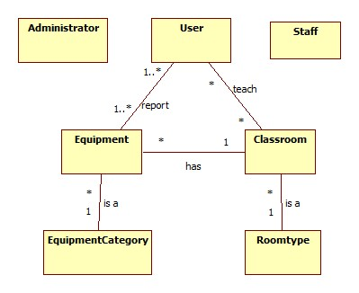

Figure 32: Conceptual Diagram